UNITED STATES
SECURITIES AND EXCHANGE COMMISSION
WASHINGTON, D.C. 20549
FORM 8-K
CURRENT REPORT
Pursuant to Section 13 or 15(d) of the Securities Exchange Act of 1934
Date of Report (Date of earliest event reported): July 14, 2026
GOSSAMER BIO, INC.
(Exact name of Registrant as Specified in Its Charter)

Delaware |  |  | 001-38796 |  |  | 47-5461709
(State or Other Jurisdiction  of Incorporation) |  |  | (Commission File Number) |  |  | (IRS Employer  Identification No.)
3115 Merryfield Row, Suite 120
San Diego, California, 92121

(Address of Principal Executive Offices) (Zip Code)
(858) 684-1300
(Registrant’s Telephone Number, Including Area Code)
N/A
(Former Name or Former Address, if Changed Since Last Report)
Check the appropriate box below if the Form 8-K filing is intended to simultaneously satisfy the filing obligation of the registrant under any of the following provisions (see General Instructions A.2. below):
☐ |  |  | Written communications pursuant to Rule 425 under the Securities Act (17 CFR 230.425)
☐ |  |  | Soliciting material pursuant to Rule 14a-12 under the Exchange Act (17 CFR 240.14a-12)
☐ |  |  | Pre-commencement communications pursuant to Rule 14d-2(b) under the Exchange Act (17 CFR 240.14d-2(b))
☐ |  |  | Pre-commencement communications pursuant to Rule 13e-4(c) under the Exchange Act (17 CFR 240.13e-4(c))
Securities registered pursuant to Section 12(b) of the Act:
Title of each class |  |  |  |  |  | Trading  Symbol(s) |  |  |  |  |  | Name of each exchange on which registered
Common Stock, $0.0001 par value per share |  |  |  |  |  | GOSS |  |  |  |  |  | Nasdaq Global Select Market
Indicate by check mark whether the registrant is an emerging growth company as defined in Rule 405 of the Securities Act of 1933 (§230.405 of this chapter) or Rule 12b-2 of the Securities Exchange Act of 1934 (§240.12b-2 of this chapter).
Emerging growth company ☐
If an emerging growth company, indicate by check mark if the registrant has elected not to use the extended transition period for complying with any new or revised financial accounting standards provided pursuant to Section 13(a) of the Exchange Act. ☐

Item 5.02 Departure of Directors or Certain Officers; Election of Directors; Appointment of Certain Officers; Compensatory Arrangements of Certain Officers.
The Board of Directors of Gossamer Bio, Inc. (the “Company”) previously approved, effective as of May 18, 2026, subject to stockholder approval and the occurrence of the closing date of the Company’s offer to exchange (the “Exchange Offer”) its outstanding $200.0 million in aggregate principal amount of 5.00% Convertible Senior Notes due 2027 (the “Existing Convertible Notes”), an amendment and restatement of the Gossamer Bio, Inc. 2019 Incentive Award Plan (the “Restated Plan”). On July 14, 2026, the Company’s stockholders approved the Restated Plan at the Company’s special meeting of stockholders held on July 14, 2026 (the “Special Meeting”), as further described below. The closing date of the Exchange Offer occurred on June 4, 2026 upon early settlement of the Exchange Offer, as no additional Existing Convertible Notes were validly tendered in the Exchange Offer thereafter. As more fully described in the Company’s “Proxy Statement for Special Meeting of Stockholders” filed on June 9, 2026 (the “Proxy Statement”), the Restated Plan increases the number of shares of the Company’s common stock, par value $0.0001 per share (the “Common Stock”), authorized for issuance thereunder.
The foregoing description of the Restated Plan is not complete and is subject to, and qualified in its entirety by, the complete text of the Restated Plan, which is filed as Exhibit 10.1 to this Current Report on Form 8-K, and incorporated herein by reference.
Item 5.03 Amendments to Articles of Incorporation or Bylaws; Change in Fiscal Year.
On July 14, 2026, following approval by the Company's stockholders at the Special Meeting, the Company filed a certificate of amendment (the “Charter Amendment”) to the Amended and Restated Certificate of Incorporation of the Company (the “Charter”) with the Secretary of State of the State of Delaware to increase the number of authorized shares of its Common Stock from 700,000,000 to 4,000,000,000 in order to support, among other things, the additional share issuances of Common Stock issuable upon conversion of the Company's newly issued 7.50% Convertible Senior Secured First Lien Notes due 2030 (the “New Convertible Notes”) and exercise of the Company’s newly issued warrants to purchase shares of Common Stock (the “Purchase Warrants”), each issued as part of the Exchange Offer, and under the Restated Plan. The Charter Amendment became effective upon filing.
The foregoing description of the Charter Amendment is not complete and is subject to, and qualified in its entirety by, the complete text of the Charter Amendment, which is filed as Exhibit 3.1 to this Current Report on Form 8-K, and incorporated herein by reference.
Item 5.07 Submission of Matters to a Vote of Security Holders.
The following is a brief description of each matter voted upon at the Special Meeting and the number of votes cast for or against, the number of abstentions and the number of broker non-votes with respect to each matter, as applicable.
1.The approval, in accordance with Nasdaq Listing Rule 5635(d), of the potential issuance of shares of Common Stock upon (i) conversion of up to $72.0 million in aggregate principal amount of New Convertible Notes and make-whole payments in the form of Common Stock, and (ii) exercise of 135,789,000 Purchase Warrants, which issuances would, in the aggregate, exceed 20% of the number of shares of Common Stock issued and outstanding immediately prior to the time of commencement of the Exchange Offer. The proposal was approved by the votes indicated:
For |  |  |  |  |  | Against |  |  |  |  |  | Abstain |  |  |  |  |  | Broker Non-Votes
321,473,747 |  |  |  |  |  | 9,152,580 |  |  |  |  |  | 568,233 |  |  |  |  |  | 77,280,015
2.The approval of the Restated Plan to increase the number of shares of Common Stock authorized for issuance thereunder. The proposal was approved by the votes indicated:
For |  |  |  |  |  | Against |  |  |  |  |  | Abstain |  |  |  |  |  | Broker Non-Votes
292,659,883 |  |  |  |  |  | 37,844,040 |  |  |  |  |  | 690,637 |  |  |  |  |  | 77,280,015
3.The approval of the Charter Amendment to increase the number of authorized shares of Common Stock from 700,000,000 to 4,000,000,000 in order to support, among other things, the additional share issuances of Common Stock issuable upon conversion of the New Convertible Notes and Purchase Warrants and under the Restated Plan. The proposal was approved by the votes indicated:
1

For |  |  |  |  |  | Against |  |  |  |  |  | Abstain |  |  |  |  |  | Broker Non-Votes
379,793,655 |  |  |  |  |  | 27,479,988 |  |  |  |  |  | 1,200,932 |  |  |  |  |  | —
4. The approval of a series of 30 alternate amendments to the Charter to effect (i) a reverse stock split of the issued and outstanding shares of Common Stock and (ii) a proportionate reduction in the number of authorized shares of Common Stock (and correspondingly decrease the total number of authorized shares of the Company’s capital stock). The proposal was approved by the votes indicated:
For |  |  |  |  |  | Against |  |  |  |  |  | Abstain |  |  |  |  |  | Broker Non-Votes
383,876,939 |  |  |  |  |  | 23,228,367 |  |  |  |  |  | 1,369,269 |  |  |  |  |  | —
Because the Company’s stockholders approved the foregoing proposals, a vote on the proposal to adjourn the Special Meeting, as described in the Proxy Statement, was not called during the Special Meeting.
Item 9.01 Financial Statements and Exhibits.
(d) Exhibits.
Exhibit  Number |  |  |  |  |  | Description
3.1 |  |  |  |  |  | Certificate of Amendment to the Amended and Restated Certificate of Incorporation of Gossamer Bio, Inc.
10.1 |  |  |  |  |  | Gossamer Bio, Inc. 2019 Incentive Award Plan, as Amended and Restated Effective May 18, 2026
104 |  |  |  |  |  | Cover page interactive data file (embedded with the inline XBRL document)
1

SIGNATURES
Pursuant to the requirements of the Securities Exchange Act of 1934, the registrant has duly caused this report to be signed on its behalf by the undersigned hereunto duly authorized.

 |  |  |  |  |  | GOSSAMER BIO, INC.
Date: July 14, 2026 |  |  |  |  |  | By: |  |  | /s/ Christian Waage
 |  |  |  |  |  |  |  |  | Christian Waage
 |  |  |  |  |  |  |  |  | Executive Vice President and General Counsel

Exhibit 3.1
2
Certificate of Amendment
of
Amended and Restated Certificate of Incorporation
of
Gossamer Bio, Inc.

Gossamer Bio, Inc. (the “Corporation”), a corporation organized and existing under and by virtue of the General Corporation Law of the State of Delaware (the “DGCL”), does hereby certify:
1. The Corporation, which was originally known as FSG Bio, Inc., originally filed its Certificate of Incorporation on October 26, 2015.
2. That the Board of Directors of said Corporation duly adopted resolutions setting forth a proposed amendment of the Amended and Restated Certificate of Incorporation of the Corporation (the “Certificate”), declaring said amendment to be advisable and directing its officers to submit said amendment to the stockholders of the Corporation for consideration thereof. The resolution setting forth the proposed amendment is as follows:
THEREFORE, BE IT RESOLVED, that the first paragraph of Article FOURTH of the Certificate is hereby amended to read in its entirety as follows:
FOURTH: The total number of shares of all classes of stock which the Corporation shall have authority to issue is 4,070,000,000 shares, consisting of (a) 4,000,000,000 shares of Common Stock, $0.0001 par value per share (“Common Stock”), and (b) 70,000,000 shares of Preferred Stock, $0.0001 par value per share (“Preferred Stock”).
3. That thereafter, pursuant to a resolution of the Board of Directors, the stockholders gave their approval of said amendment at a meeting of stockholders in accordance with the provisions of Section 211 of the DGCL.
4. This Certificate of Amendment was duly adopted in accordance with Section 242 of the DGCL. The Board of Directors of the Corporation duly adopted resolutions setting forth and declaring advisable this Certificate of Amendment and directed that such amendment be considered by the stockholders of the Corporation. A special meeting of stockholders was duly called upon notice in accordance with Section 222 of the DGCL and held on July 14, 2026, at which meeting the necessary number of shares were voted in favor of such amendment. The stockholders of the Corporation duly adopted this Certificate of Amendment.
5. This Certificate of Amendment shall become effective upon filing with the Secretary of State of the State of Delaware.
[Signature page follows]

IN WITNESS WHEREOF, this Certificate of Amendment of Amended and Restated Certificate of Incorporation has been executed as of this 14th day of July, 2026.
 |  |  |  |  |  | Gossamer Bio, Inc.
 |  |  |  |  |  | A Delaware corporation
 |  |  |  |  |  | By: |  |  | /s/ Christian Waage
 |  |  |  |  |  |  |  |  | Name: Christian Waage
 |  |  |  |  |  |  |  |  | Title: Executive Vice President and General Counsel

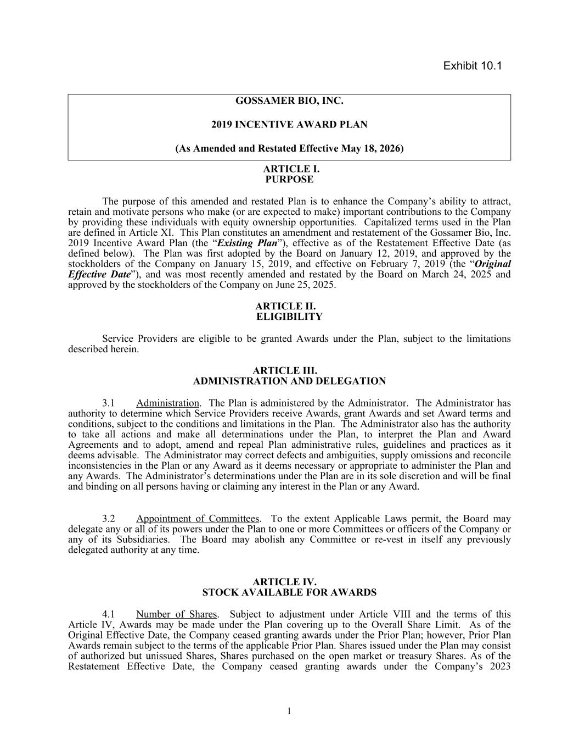

GOSSAMER BIO, INC. 2019 INCENTIVE AWARD PLAN (As Amended and Restated Effective May 18, 2026) ARTICLE I. PURPOSE The purpose of this amended and restated Plan is to enhance the Company’s ability to attract, retain and motivate persons who make (or are expected to make) important contributions to the Company by providing these individuals with equity ownership opportunities. Capitalized terms used in the Plan are defined in Article XI. This Plan constitutes an amendment and restatement of the Gossamer Bio, Inc. 2019 Incentive Award Plan (the “Existing Plan”), effective as of the Restatement Effective Date (as defined below). The Plan was first adopted by the Board on January 12, 2019, and approved by the stockholders of the Company on January 15, 2019, and effective on February 7, 2019 (the “Original Effective Date”), and was most recently amended and restated by the Board on March 24, 2025 and approved by the stockholders of the Company on June 25, 2025. ARTICLE II. ELIGIBILITY Service Providers are eligible to be granted Awards under the Plan, subject to the limitations described herein. ARTICLE III. ADMINISTRATION AND DELEGATION 3.1 Administration. The Plan is administered by the Administrator. The Administrator has authority to determine which Service Providers receive Awards, grant Awards and set Award terms and conditions, subject to the conditions and limitations in the Plan. The Administrator also has the authority to take all actions and make all determinations under the Plan, to interpret the Plan and Award Agreements and to adopt, amend and repeal Plan administrative rules, guidelines and practices as it deems advisable. The Administrator may correct defects and ambiguities, supply omissions and reconcile inconsistencies in the Plan or any Award as it deems necessary or appropriate to administer the Plan and any Awards. The Administrator’s determinations under the Plan are in its sole discretion and will be final and binding on all persons having or claiming any interest in the Plan or any Award. 3.2 Appointment of Committees. To the extent Applicable Laws permit, the Board may delegate any or all of its powers under the Plan to one or more Committees or officers of the Company or any of its Subsidiaries. The Board may abolish any Committee or re-vest in itself any previously delegated authority at any time. ARTICLE IV. STOCK AVAILABLE FOR AWARDS 4.1 Number of Shares. Subject to adjustment under Article VIII and the terms of this Article IV, Awards may be made under the Plan covering up to the Overall Share Limit. As of the Original Effective Date, the Company ceased granting awards under the Prior Plan; however, Prior Plan Awards remain subject to the terms of the applicable Prior Plan. Shares issued under the Plan may consist of authorized but unissued Shares, Shares purchased on the open market or treasury Shares. As of the Restatement Effective Date, the Company ceased granting awards under the Company’s 2023 1 Exhibit 10.1

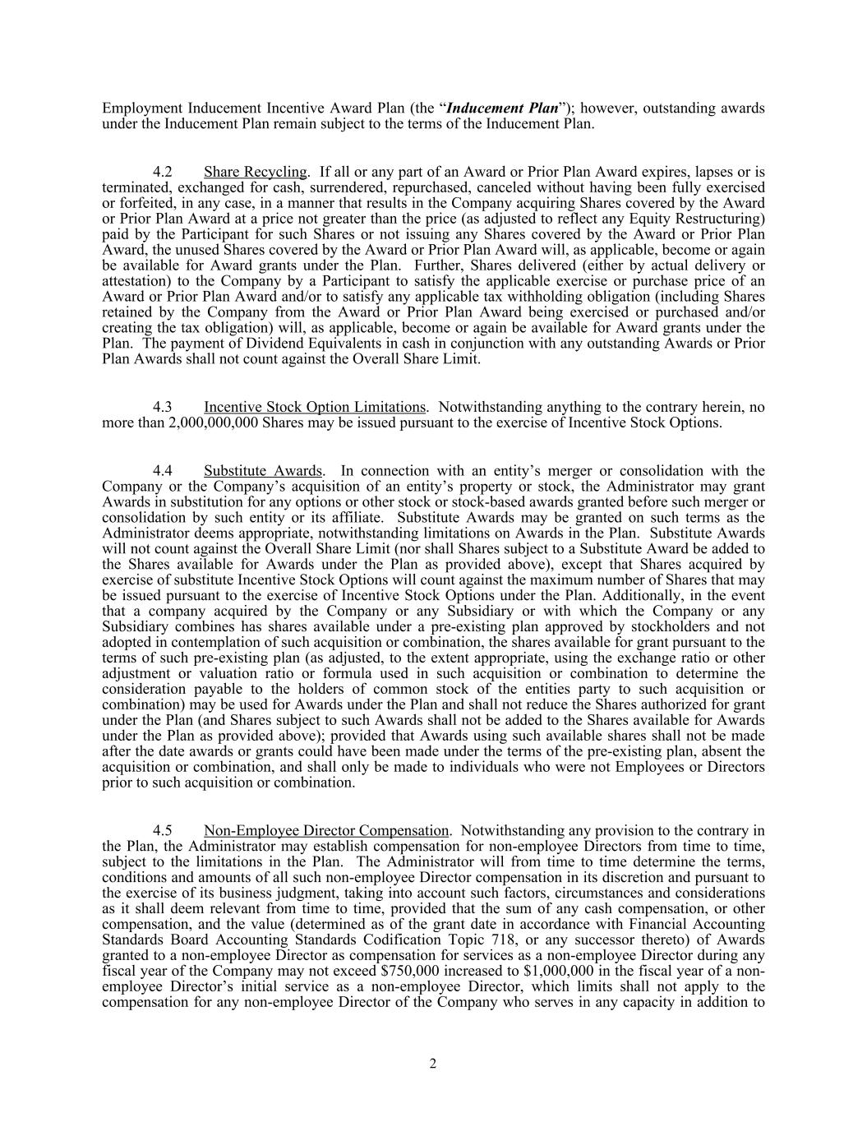
Employment Inducement Incentive Award Plan (the “Inducement Plan”); however, outstanding awards under the Inducement Plan remain subject to the terms of the Inducement Plan. 4.2 Share Recycling. If all or any part of an Award or Prior Plan Award expires, lapses or is terminated, exchanged for cash, surrendered, repurchased, canceled without having been fully exercised or forfeited, in any case, in a manner that results in the Company acquiring Shares covered by the Award or Prior Plan Award at a price not greater than the price (as adjusted to reflect any Equity Restructuring) paid by the Participant for such Shares or not issuing any Shares covered by the Award or Prior Plan Award, the unused Shares covered by the Award or Prior Plan Award will, as applicable, become or again be available for Award grants under the Plan. Further, Shares delivered (either by actual delivery or attestation) to the Company by a Participant to satisfy the applicable exercise or purchase price of an Award or Prior Plan Award and/or to satisfy any applicable tax withholding obligation (including Shares retained by the Company from the Award or Prior Plan Award being exercised or purchased and/or creating the tax obligation) will, as applicable, become or again be available for Award grants under the Plan. The payment of Dividend Equivalents in cash in conjunction with any outstanding Awards or Prior Plan Awards shall not count against the Overall Share Limit. 4.3 Incentive Stock Option Limitations. Notwithstanding anything to the contrary herein, no more than 2,000,000,000 Shares may be issued pursuant to the exercise of Incentive Stock Options. 4.4 Substitute Awards. In connection with an entity’s merger or consolidation with the Company or the Company’s acquisition of an entity’s property or stock, the Administrator may grant Awards in substitution for any options or other stock or stock-based awards granted before such merger or consolidation by such entity or its affiliate. Substitute Awards may be granted on such terms as the Administrator deems appropriate, notwithstanding limitations on Awards in the Plan. Substitute Awards will not count against the Overall Share Limit (nor shall Shares subject to a Substitute Award be added to the Shares available for Awards under the Plan as provided above), except that Shares acquired by exercise of substitute Incentive Stock Options will count against the maximum number of Shares that may be issued pursuant to the exercise of Incentive Stock Options under the Plan. Additionally, in the event that a company acquired by the Company or any Subsidiary or with which the Company or any Subsidiary combines has shares available under a pre-existing plan approved by stockholders and not adopted in contemplation of such acquisition or combination, the shares available for grant pursuant to the terms of such pre-existing plan (as adjusted, to the extent appropriate, using the exchange ratio or other adjustment or valuation ratio or formula used in such acquisition or combination to determine the consideration payable to the holders of common stock of the entities party to such acquisition or combination) may be used for Awards under the Plan and shall not reduce the Shares authorized for grant under the Plan (and Shares subject to such Awards shall not be added to the Shares available for Awards under the Plan as provided above); provided that Awards using such available shares shall not be made after the date awards or grants could have been made under the terms of the pre-existing plan, absent the acquisition or combination, and shall only be made to individuals who were not Employees or Directors prior to such acquisition or combination. 4.5 Non-Employee Director Compensation. Notwithstanding any provision to the contrary in the Plan, the Administrator may establish compensation for non-employee Directors from time to time, subject to the limitations in the Plan. The Administrator will from time to time determine the terms, conditions and amounts of all such non-employee Director compensation in its discretion and pursuant to the exercise of its business judgment, taking into account such factors, circumstances and considerations as it shall deem relevant from time to time, provided that the sum of any cash compensation, or other compensation, and the value (determined as of the grant date in accordance with Financial Accounting Standards Board Accounting Standards Codification Topic 718, or any successor thereto) of Awards granted to a non-employee Director as compensation for services as a non-employee Director during any fiscal year of the Company may not exceed $750,000 increased to $1,000,000 in the fiscal year of a non- employee Director’s initial service as a non-employee Director, which limits shall not apply to the compensation for any non-employee Director of the Company who serves in any capacity in addition to 2

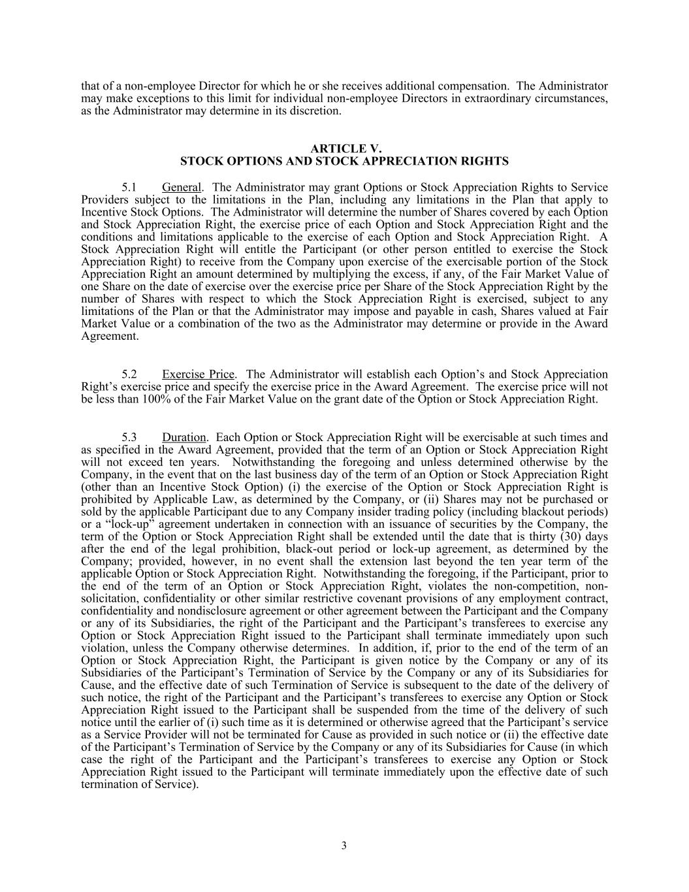
that of a non-employee Director for which he or she receives additional compensation. The Administrator may make exceptions to this limit for individual non-employee Directors in extraordinary circumstances, as the Administrator may determine in its discretion. ARTICLE V. STOCK OPTIONS AND STOCK APPRECIATION RIGHTS 5.1 General. The Administrator may grant Options or Stock Appreciation Rights to Service Providers subject to the limitations in the Plan, including any limitations in the Plan that apply to Incentive Stock Options. The Administrator will determine the number of Shares covered by each Option and Stock Appreciation Right, the exercise price of each Option and Stock Appreciation Right and the conditions and limitations applicable to the exercise of each Option and Stock Appreciation Right. A Stock Appreciation Right will entitle the Participant (or other person entitled to exercise the Stock Appreciation Right) to receive from the Company upon exercise of the exercisable portion of the Stock Appreciation Right an amount determined by multiplying the excess, if any, of the Fair Market Value of one Share on the date of exercise over the exercise price per Share of the Stock Appreciation Right by the number of Shares with respect to which the Stock Appreciation Right is exercised, subject to any limitations of the Plan or that the Administrator may impose and payable in cash, Shares valued at Fair Market Value or a combination of the two as the Administrator may determine or provide in the Award Agreement. 5.2 Exercise Price. The Administrator will establish each Option’s and Stock Appreciation Right’s exercise price and specify the exercise price in the Award Agreement. The exercise price will not be less than 100% of the Fair Market Value on the grant date of the Option or Stock Appreciation Right. 5.3 Duration. Each Option or Stock Appreciation Right will be exercisable at such times and as specified in the Award Agreement, provided that the term of an Option or Stock Appreciation Right will not exceed ten years. Notwithstanding the foregoing and unless determined otherwise by the Company, in the event that on the last business day of the term of an Option or Stock Appreciation Right (other than an Incentive Stock Option) (i) the exercise of the Option or Stock Appreciation Right is prohibited by Applicable Law, as determined by the Company, or (ii) Shares may not be purchased or sold by the applicable Participant due to any Company insider trading policy (including blackout periods) or a “lock-up” agreement undertaken in connection with an issuance of securities by the Company, the term of the Option or Stock Appreciation Right shall be extended until the date that is thirty (30) days after the end of the legal prohibition, black-out period or lock-up agreement, as determined by the Company; provided, however, in no event shall the extension last beyond the ten year term of the applicable Option or Stock Appreciation Right. Notwithstanding the foregoing, if the Participant, prior to the end of the term of an Option or Stock Appreciation Right, violates the non-competition, non- solicitation, confidentiality or other similar restrictive covenant provisions of any employment contract, confidentiality and nondisclosure agreement or other agreement between the Participant and the Company or any of its Subsidiaries, the right of the Participant and the Participant’s transferees to exercise any Option or Stock Appreciation Right issued to the Participant shall terminate immediately upon such violation, unless the Company otherwise determines. In addition, if, prior to the end of the term of an Option or Stock Appreciation Right, the Participant is given notice by the Company or any of its Subsidiaries of the Participant’s Termination of Service by the Company or any of its Subsidiaries for Cause, and the effective date of such Termination of Service is subsequent to the date of the delivery of such notice, the right of the Participant and the Participant’s transferees to exercise any Option or Stock Appreciation Right issued to the Participant shall be suspended from the time of the delivery of such notice until the earlier of (i) such time as it is determined or otherwise agreed that the Participant’s service as a Service Provider will not be terminated for Cause as provided in such notice or (ii) the effective date of the Participant’s Termination of Service by the Company or any of its Subsidiaries for Cause (in which case the right of the Participant and the Participant’s transferees to exercise any Option or Stock Appreciation Right issued to the Participant will terminate immediately upon the effective date of such termination of Service). 3

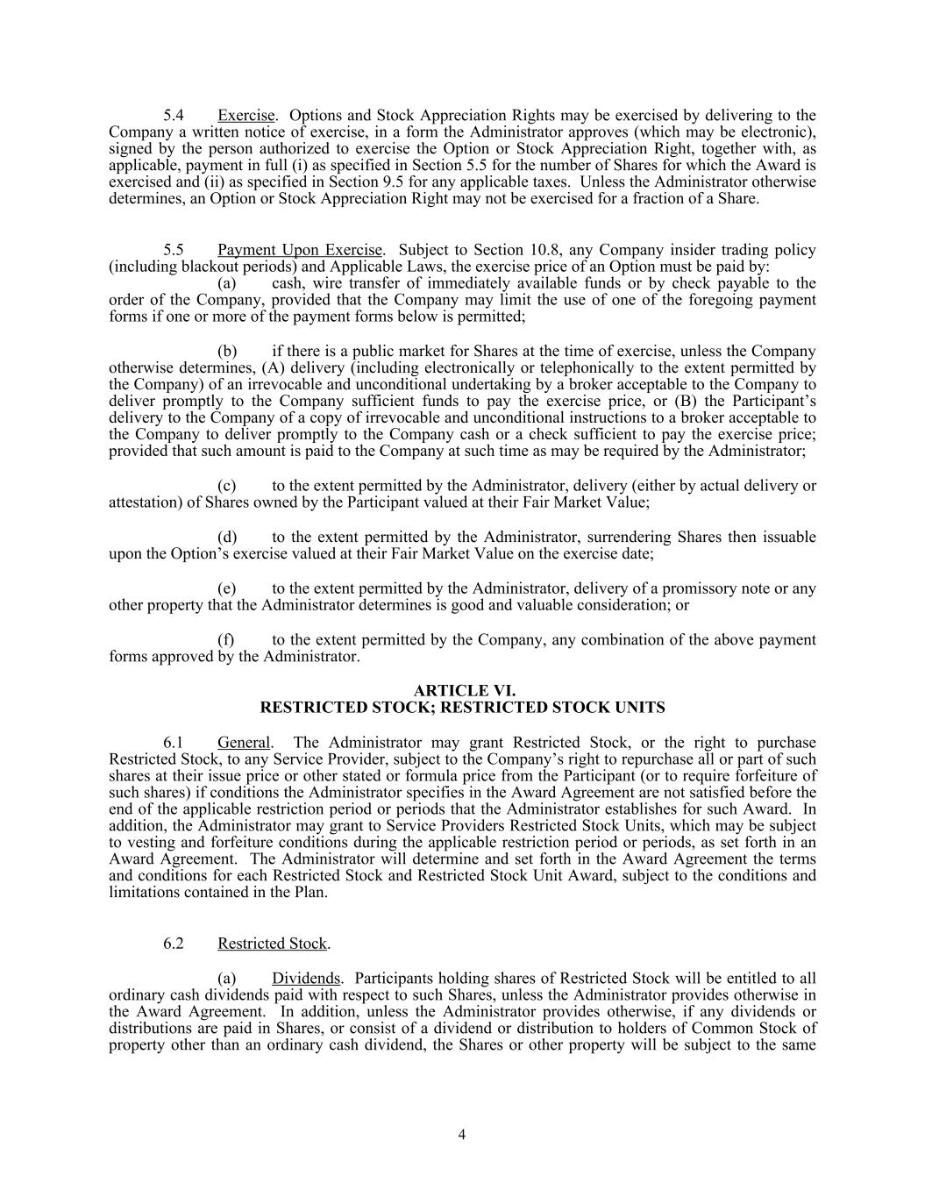
5.4 Exercise. Options and Stock Appreciation Rights may be exercised by delivering to the Company a written notice of exercise, in a form the Administrator approves (which may be electronic), signed by the person authorized to exercise the Option or Stock Appreciation Right, together with, as applicable, payment in full (i) as specified in Section 5.5 for the number of Shares for which the Award is exercised and (ii) as specified in Section 9.5 for any applicable taxes. Unless the Administrator otherwise determines, an Option or Stock Appreciation Right may not be exercised for a fraction of a Share. 5.5 Payment Upon Exercise. Subject to Section 10.8, any Company insider trading policy (including blackout periods) and Applicable Laws, the exercise price of an Option must be paid by: (a) cash, wire transfer of immediately available funds or by check payable to the order of the Company, provided that the Company may limit the use of one of the foregoing payment forms if one or more of the payment forms below is permitted; (b) if there is a public market for Shares at the time of exercise, unless the Company otherwise determines, (A) delivery (including electronically or telephonically to the extent permitted by the Company) of an irrevocable and unconditional undertaking by a broker acceptable to the Company to deliver promptly to the Company sufficient funds to pay the exercise price, or (B) the Participant’s delivery to the Company of a copy of irrevocable and unconditional instructions to a broker acceptable to the Company to deliver promptly to the Company cash or a check sufficient to pay the exercise price; provided that such amount is paid to the Company at such time as may be required by the Administrator; (c) to the extent permitted by the Administrator, delivery (either by actual delivery or attestation) of Shares owned by the Participant valued at their Fair Market Value; (d) to the extent permitted by the Administrator, surrendering Shares then issuable upon the Option’s exercise valued at their Fair Market Value on the exercise date; (e) to the extent permitted by the Administrator, delivery of a promissory note or any other property that the Administrator determines is good and valuable consideration; or (f) to the extent permitted by the Company, any combination of the above payment forms approved by the Administrator. ARTICLE VI. RESTRICTED STOCK; RESTRICTED STOCK UNITS 6.1 General. The Administrator may grant Restricted Stock, or the right to purchase Restricted Stock, to any Service Provider, subject to the Company’s right to repurchase all or part of such shares at their issue price or other stated or formula price from the Participant (or to require forfeiture of such shares) if conditions the Administrator specifies in the Award Agreement are not satisfied before the end of the applicable restriction period or periods that the Administrator establishes for such Award. In addition, the Administrator may grant to Service Providers Restricted Stock Units, which may be subject to vesting and forfeiture conditions during the applicable restriction period or periods, as set forth in an Award Agreement. The Administrator will determine and set forth in the Award Agreement the terms and conditions for each Restricted Stock and Restricted Stock Unit Award, subject to the conditions and limitations contained in the Plan. 6.2 Restricted Stock. (a) Dividends. Participants holding shares of Restricted Stock will be entitled to all ordinary cash dividends paid with respect to such Shares, unless the Administrator provides otherwise in the Award Agreement. In addition, unless the Administrator provides otherwise, if any dividends or distributions are paid in Shares, or consist of a dividend or distribution to holders of Common Stock of property other than an ordinary cash dividend, the Shares or other property will be subject to the same 4

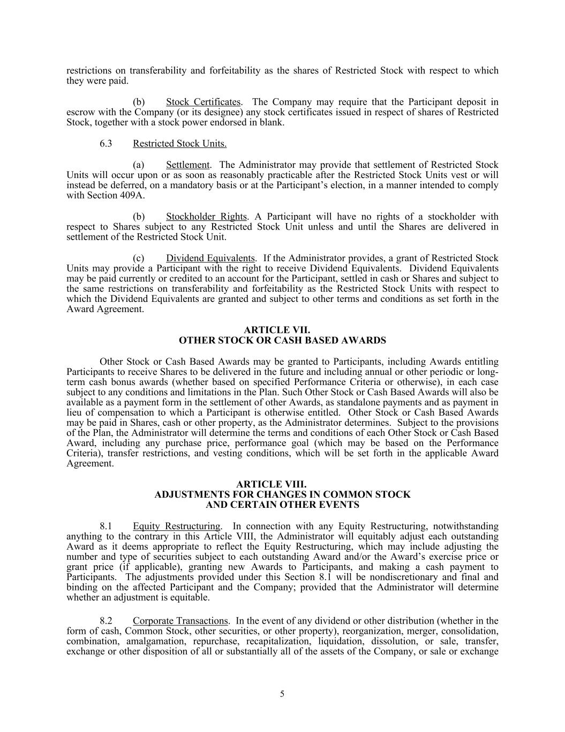
restrictions on transferability and forfeitability as the shares of Restricted Stock with respect to which they were paid. (b) Stock Certificates. The Company may require that the Participant deposit in escrow with the Company (or its designee) any stock certificates issued in respect of shares of Restricted Stock, together with a stock power endorsed in blank. 6.3 Restricted Stock Units. (a) Settlement. The Administrator may provide that settlement of Restricted Stock Units will occur upon or as soon as reasonably practicable after the Restricted Stock Units vest or will instead be deferred, on a mandatory basis or at the Participant’s election, in a manner intended to comply with Section 409A. (b) Stockholder Rights. A Participant will have no rights of a stockholder with respect to Shares subject to any Restricted Stock Unit unless and until the Shares are delivered in settlement of the Restricted Stock Unit. (c) Dividend Equivalents. If the Administrator provides, a grant of Restricted Stock Units may provide a Participant with the right to receive Dividend Equivalents. Dividend Equivalents may be paid currently or credited to an account for the Participant, settled in cash or Shares and subject to the same restrictions on transferability and forfeitability as the Restricted Stock Units with respect to which the Dividend Equivalents are granted and subject to other terms and conditions as set forth in the Award Agreement. ARTICLE VII. OTHER STOCK OR CASH BASED AWARDS Other Stock or Cash Based Awards may be granted to Participants, including Awards entitling Participants to receive Shares to be delivered in the future and including annual or other periodic or long- term cash bonus awards (whether based on specified Performance Criteria or otherwise), in each case subject to any conditions and limitations in the Plan. Such Other Stock or Cash Based Awards will also be available as a payment form in the settlement of other Awards, as standalone payments and as payment in lieu of compensation to which a Participant is otherwise entitled. Other Stock or Cash Based Awards may be paid in Shares, cash or other property, as the Administrator determines. Subject to the provisions of the Plan, the Administrator will determine the terms and conditions of each Other Stock or Cash Based Award, including any purchase price, performance goal (which may be based on the Performance Criteria), transfer restrictions, and vesting conditions, which will be set forth in the applicable Award Agreement. ARTICLE VIII. ADJUSTMENTS FOR CHANGES IN COMMON STOCK AND CERTAIN OTHER EVENTS 8.1 Equity Restructuring. In connection with any Equity Restructuring, notwithstanding anything to the contrary in this Article VIII, the Administrator will equitably adjust each outstanding Award as it deems appropriate to reflect the Equity Restructuring, which may include adjusting the number and type of securities subject to each outstanding Award and/or the Award’s exercise price or grant price (if applicable), granting new Awards to Participants, and making a cash payment to Participants. The adjustments provided under this Section 8.1 will be nondiscretionary and final and binding on the affected Participant and the Company; provided that the Administrator will determine whether an adjustment is equitable. 8.2 Corporate Transactions. In the event of any dividend or other distribution (whether in the form of cash, Common Stock, other securities, or other property), reorganization, merger, consolidation, combination, amalgamation, repurchase, recapitalization, liquidation, dissolution, or sale, transfer, exchange or other disposition of all or substantially all of the assets of the Company, or sale or exchange 5

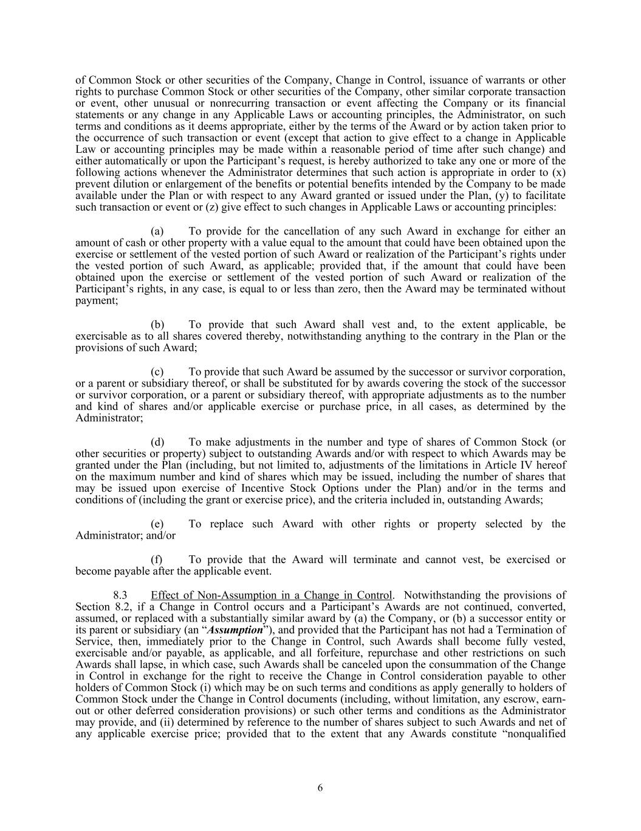
of Common Stock or other securities of the Company, Change in Control, issuance of warrants or other rights to purchase Common Stock or other securities of the Company, other similar corporate transaction or event, other unusual or nonrecurring transaction or event affecting the Company or its financial statements or any change in any Applicable Laws or accounting principles, the Administrator, on such terms and conditions as it deems appropriate, either by the terms of the Award or by action taken prior to the occurrence of such transaction or event (except that action to give effect to a change in Applicable Law or accounting principles may be made within a reasonable period of time after such change) and either automatically or upon the Participant’s request, is hereby authorized to take any one or more of the following actions whenever the Administrator determines that such action is appropriate in order to (x) prevent dilution or enlargement of the benefits or potential benefits intended by the Company to be made available under the Plan or with respect to any Award granted or issued under the Plan, (y) to facilitate such transaction or event or (z) give effect to such changes in Applicable Laws or accounting principles: (a) To provide for the cancellation of any such Award in exchange for either an amount of cash or other property with a value equal to the amount that could have been obtained upon the exercise or settlement of the vested portion of such Award or realization of the Participant’s rights under the vested portion of such Award, as applicable; provided that, if the amount that could have been obtained upon the exercise or settlement of the vested portion of such Award or realization of the Participant’s rights, in any case, is equal to or less than zero, then the Award may be terminated without payment; (b) To provide that such Award shall vest and, to the extent applicable, be exercisable as to all shares covered thereby, notwithstanding anything to the contrary in the Plan or the provisions of such Award; (c) To provide that such Award be assumed by the successor or survivor corporation, or a parent or subsidiary thereof, or shall be substituted for by awards covering the stock of the successor or survivor corporation, or a parent or subsidiary thereof, with appropriate adjustments as to the number and kind of shares and/or applicable exercise or purchase price, in all cases, as determined by the Administrator; (d) To make adjustments in the number and type of shares of Common Stock (or other securities or property) subject to outstanding Awards and/or with respect to which Awards may be granted under the Plan (including, but not limited to, adjustments of the limitations in Article IV hereof on the maximum number and kind of shares which may be issued, including the number of shares that may be issued upon exercise of Incentive Stock Options under the Plan) and/or in the terms and conditions of (including the grant or exercise price), and the criteria included in, outstanding Awards; (e) To replace such Award with other rights or property selected by the Administrator; and/or (f) To provide that the Award will terminate and cannot vest, be exercised or become payable after the applicable event. 8.3 Effect of Non-Assumption in a Change in Control. Notwithstanding the provisions of Section 8.2, if a Change in Control occurs and a Participant’s Awards are not continued, converted, assumed, or replaced with a substantially similar award by (a) the Company, or (b) a successor entity or its parent or subsidiary (an “Assumption”), and provided that the Participant has not had a Termination of Service, then, immediately prior to the Change in Control, such Awards shall become fully vested, exercisable and/or payable, as applicable, and all forfeiture, repurchase and other restrictions on such Awards shall lapse, in which case, such Awards shall be canceled upon the consummation of the Change in Control in exchange for the right to receive the Change in Control consideration payable to other holders of Common Stock (i) which may be on such terms and conditions as apply generally to holders of Common Stock under the Change in Control documents (including, without limitation, any escrow, earn- out or other deferred consideration provisions) or such other terms and conditions as the Administrator may provide, and (ii) determined by reference to the number of shares subject to such Awards and net of any applicable exercise price; provided that to the extent that any Awards constitute “nonqualified 6

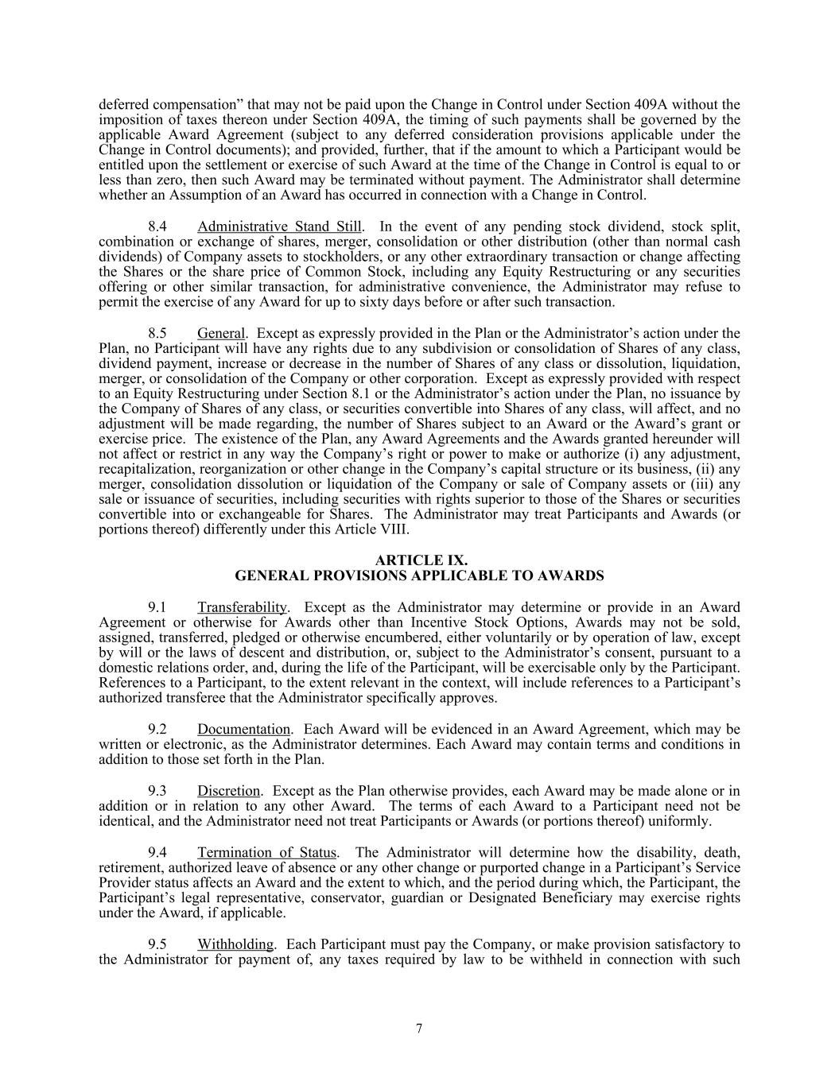
deferred compensation” that may not be paid upon the Change in Control under Section 409A without the imposition of taxes thereon under Section 409A, the timing of such payments shall be governed by the applicable Award Agreement (subject to any deferred consideration provisions applicable under the Change in Control documents); and provided, further, that if the amount to which a Participant would be entitled upon the settlement or exercise of such Award at the time of the Change in Control is equal to or less than zero, then such Award may be terminated without payment. The Administrator shall determine whether an Assumption of an Award has occurred in connection with a Change in Control. 8.4 Administrative Stand Still. In the event of any pending stock dividend, stock split, combination or exchange of shares, merger, consolidation or other distribution (other than normal cash dividends) of Company assets to stockholders, or any other extraordinary transaction or change affecting the Shares or the share price of Common Stock, including any Equity Restructuring or any securities offering or other similar transaction, for administrative convenience, the Administrator may refuse to permit the exercise of any Award for up to sixty days before or after such transaction. 8.5 General. Except as expressly provided in the Plan or the Administrator’s action under the Plan, no Participant will have any rights due to any subdivision or consolidation of Shares of any class, dividend payment, increase or decrease in the number of Shares of any class or dissolution, liquidation, merger, or consolidation of the Company or other corporation. Except as expressly provided with respect to an Equity Restructuring under Section 8.1 or the Administrator’s action under the Plan, no issuance by the Company of Shares of any class, or securities convertible into Shares of any class, will affect, and no adjustment will be made regarding, the number of Shares subject to an Award or the Award’s grant or exercise price. The existence of the Plan, any Award Agreements and the Awards granted hereunder will not affect or restrict in any way the Company’s right or power to make or authorize (i) any adjustment, recapitalization, reorganization or other change in the Company’s capital structure or its business, (ii) any merger, consolidation dissolution or liquidation of the Company or sale of Company assets or (iii) any sale or issuance of securities, including securities with rights superior to those of the Shares or securities convertible into or exchangeable for Shares. The Administrator may treat Participants and Awards (or portions thereof) differently under this Article VIII. ARTICLE IX. GENERAL PROVISIONS APPLICABLE TO AWARDS 9.1 Transferability. Except as the Administrator may determine or provide in an Award Agreement or otherwise for Awards other than Incentive Stock Options, Awards may not be sold, assigned, transferred, pledged or otherwise encumbered, either voluntarily or by operation of law, except by will or the laws of descent and distribution, or, subject to the Administrator’s consent, pursuant to a domestic relations order, and, during the life of the Participant, will be exercisable only by the Participant. References to a Participant, to the extent relevant in the context, will include references to a Participant’s authorized transferee that the Administrator specifically approves. 9.2 Documentation. Each Award will be evidenced in an Award Agreement, which may be written or electronic, as the Administrator determines. Each Award may contain terms and conditions in addition to those set forth in the Plan. 9.3 Discretion. Except as the Plan otherwise provides, each Award may be made alone or in addition or in relation to any other Award. The terms of each Award to a Participant need not be identical, and the Administrator need not treat Participants or Awards (or portions thereof) uniformly. 9.4 Termination of Status. The Administrator will determine how the disability, death, retirement, authorized leave of absence or any other change or purported change in a Participant’s Service Provider status affects an Award and the extent to which, and the period during which, the Participant, the Participant’s legal representative, conservator, guardian or Designated Beneficiary may exercise rights under the Award, if applicable. 9.5 Withholding. Each Participant must pay the Company, or make provision satisfactory to the Administrator for payment of, any taxes required by law to be withheld in connection with such 7

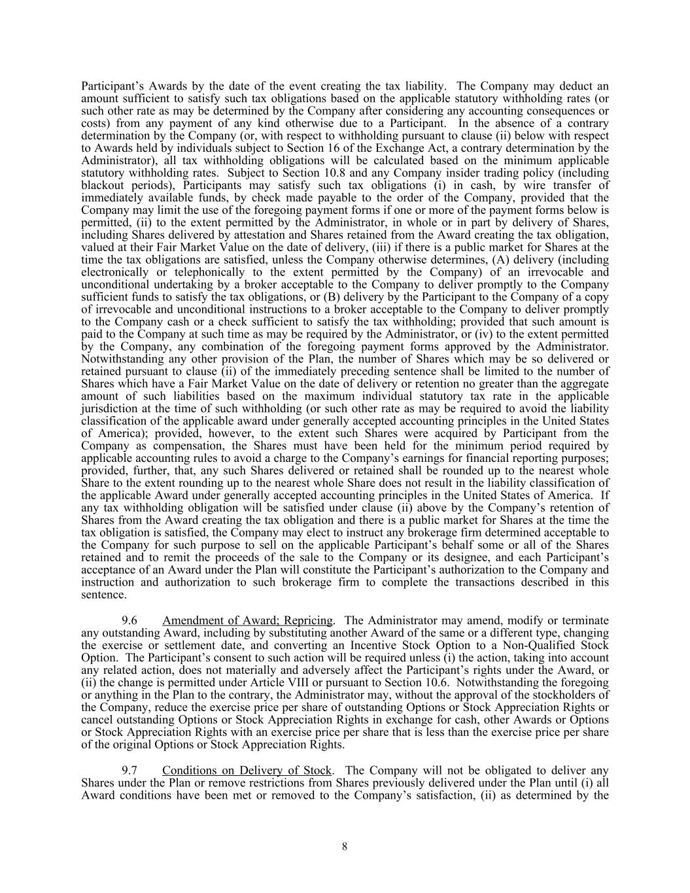
Participant’s Awards by the date of the event creating the tax liability. The Company may deduct an amount sufficient to satisfy such tax obligations based on the applicable statutory withholding rates (or such other rate as may be determined by the Company after considering any accounting consequences or costs) from any payment of any kind otherwise due to a Participant. In the absence of a contrary determination by the Company (or, with respect to withholding pursuant to clause (ii) below with respect to Awards held by individuals subject to Section 16 of the Exchange Act, a contrary determination by the Administrator), all tax withholding obligations will be calculated based on the minimum applicable statutory withholding rates. Subject to Section 10.8 and any Company insider trading policy (including blackout periods), Participants may satisfy such tax obligations (i) in cash, by wire transfer of immediately available funds, by check made payable to the order of the Company, provided that the Company may limit the use of the foregoing payment forms if one or more of the payment forms below is permitted, (ii) to the extent permitted by the Administrator, in whole or in part by delivery of Shares, including Shares delivered by attestation and Shares retained from the Award creating the tax obligation, valued at their Fair Market Value on the date of delivery, (iii) if there is a public market for Shares at the time the tax obligations are satisfied, unless the Company otherwise determines, (A) delivery (including electronically or telephonically to the extent permitted by the Company) of an irrevocable and unconditional undertaking by a broker acceptable to the Company to deliver promptly to the Company sufficient funds to satisfy the tax obligations, or (B) delivery by the Participant to the Company of a copy of irrevocable and unconditional instructions to a broker acceptable to the Company to deliver promptly to the Company cash or a check sufficient to satisfy the tax withholding; provided that such amount is paid to the Company at such time as may be required by the Administrator, or (iv) to the extent permitted by the Company, any combination of the foregoing payment forms approved by the Administrator. Notwithstanding any other provision of the Plan, the number of Shares which may be so delivered or retained pursuant to clause (ii) of the immediately preceding sentence shall be limited to the number of Shares which have a Fair Market Value on the date of delivery or retention no greater than the aggregate amount of such liabilities based on the maximum individual statutory tax rate in the applicable jurisdiction at the time of such withholding (or such other rate as may be required to avoid the liability classification of the applicable award under generally accepted accounting principles in the United States of America); provided, however, to the extent such Shares were acquired by Participant from the Company as compensation, the Shares must have been held for the minimum period required by applicable accounting rules to avoid a charge to the Company’s earnings for financial reporting purposes; provided, further, that, any such Shares delivered or retained shall be rounded up to the nearest whole Share to the extent rounding up to the nearest whole Share does not result in the liability classification of the applicable Award under generally accepted accounting principles in the United States of America. If any tax withholding obligation will be satisfied under clause (ii) above by the Company’s retention of Shares from the Award creating the tax obligation and there is a public market for Shares at the time the tax obligation is satisfied, the Company may elect to instruct any brokerage firm determined acceptable to the Company for such purpose to sell on the applicable Participant’s behalf some or all of the Shares retained and to remit the proceeds of the sale to the Company or its designee, and each Participant’s acceptance of an Award under the Plan will constitute the Participant’s authorization to the Company and instruction and authorization to such brokerage firm to complete the transactions described in this sentence. 9.6 Amendment of Award; Repricing. The Administrator may amend, modify or terminate any outstanding Award, including by substituting another Award of the same or a different type, changing the exercise or settlement date, and converting an Incentive Stock Option to a Non-Qualified Stock Option. The Participant’s consent to such action will be required unless (i) the action, taking into account any related action, does not materially and adversely affect the Participant’s rights under the Award, or (ii) the change is permitted under Article VIII or pursuant to Section 10.6. Notwithstanding the foregoing or anything in the Plan to the contrary, the Administrator may, without the approval of the stockholders of the Company, reduce the exercise price per share of outstanding Options or Stock Appreciation Rights or cancel outstanding Options or Stock Appreciation Rights in exchange for cash, other Awards or Options or Stock Appreciation Rights with an exercise price per share that is less than the exercise price per share of the original Options or Stock Appreciation Rights. 9.7 Conditions on Delivery of Stock. The Company will not be obligated to deliver any Shares under the Plan or remove restrictions from Shares previously delivered under the Plan until (i) all Award conditions have been met or removed to the Company’s satisfaction, (ii) as determined by the 8

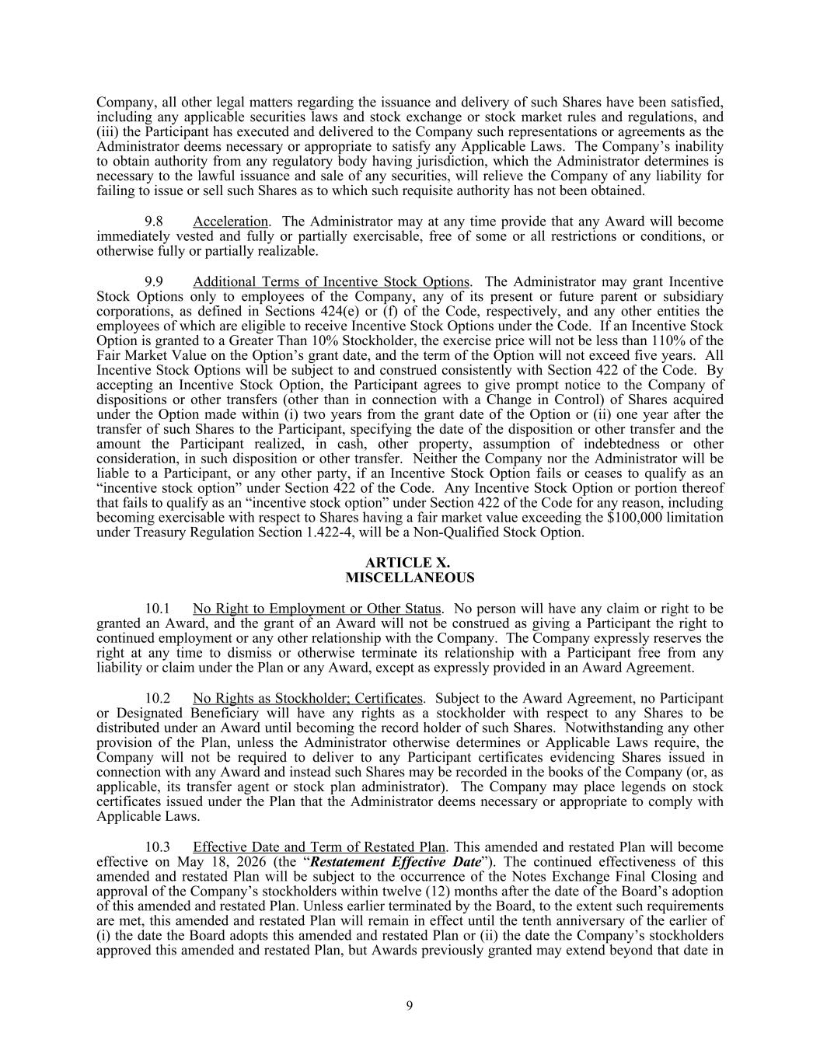
Company, all other legal matters regarding the issuance and delivery of such Shares have been satisfied, including any applicable securities laws and stock exchange or stock market rules and regulations, and (iii) the Participant has executed and delivered to the Company such representations or agreements as the Administrator deems necessary or appropriate to satisfy any Applicable Laws. The Company’s inability to obtain authority from any regulatory body having jurisdiction, which the Administrator determines is necessary to the lawful issuance and sale of any securities, will relieve the Company of any liability for failing to issue or sell such Shares as to which such requisite authority has not been obtained. 9.8 Acceleration. The Administrator may at any time provide that any Award will become immediately vested and fully or partially exercisable, free of some or all restrictions or conditions, or otherwise fully or partially realizable. 9.9 Additional Terms of Incentive Stock Options. The Administrator may grant Incentive Stock Options only to employees of the Company, any of its present or future parent or subsidiary corporations, as defined in Sections 424(e) or (f) of the Code, respectively, and any other entities the employees of which are eligible to receive Incentive Stock Options under the Code. If an Incentive Stock Option is granted to a Greater Than 10% Stockholder, the exercise price will not be less than 110% of the Fair Market Value on the Option’s grant date, and the term of the Option will not exceed five years. All Incentive Stock Options will be subject to and construed consistently with Section 422 of the Code. By accepting an Incentive Stock Option, the Participant agrees to give prompt notice to the Company of dispositions or other transfers (other than in connection with a Change in Control) of Shares acquired under the Option made within (i) two years from the grant date of the Option or (ii) one year after the transfer of such Shares to the Participant, specifying the date of the disposition or other transfer and the amount the Participant realized, in cash, other property, assumption of indebtedness or other consideration, in such disposition or other transfer. Neither the Company nor the Administrator will be liable to a Participant, or any other party, if an Incentive Stock Option fails or ceases to qualify as an “incentive stock option” under Section 422 of the Code. Any Incentive Stock Option or portion thereof that fails to qualify as an “incentive stock option” under Section 422 of the Code for any reason, including becoming exercisable with respect to Shares having a fair market value exceeding the $100,000 limitation under Treasury Regulation Section 1.422-4, will be a Non-Qualified Stock Option. ARTICLE X. MISCELLANEOUS 10.1 No Right to Employment or Other Status. No person will have any claim or right to be granted an Award, and the grant of an Award will not be construed as giving a Participant the right to continued employment or any other relationship with the Company. The Company expressly reserves the right at any time to dismiss or otherwise terminate its relationship with a Participant free from any liability or claim under the Plan or any Award, except as expressly provided in an Award Agreement. 10.2 No Rights as Stockholder; Certificates. Subject to the Award Agreement, no Participant or Designated Beneficiary will have any rights as a stockholder with respect to any Shares to be distributed under an Award until becoming the record holder of such Shares. Notwithstanding any other provision of the Plan, unless the Administrator otherwise determines or Applicable Laws require, the Company will not be required to deliver to any Participant certificates evidencing Shares issued in connection with any Award and instead such Shares may be recorded in the books of the Company (or, as applicable, its transfer agent or stock plan administrator). The Company may place legends on stock certificates issued under the Plan that the Administrator deems necessary or appropriate to comply with Applicable Laws. 10.3 Effective Date and Term of Restated Plan. This amended and restated Plan will become effective on May 18, 2026 (the “Restatement Effective Date”). The continued effectiveness of this amended and restated Plan will be subject to the occurrence of the Notes Exchange Final Closing and approval of the Company’s stockholders within twelve (12) months after the date of the Board’s adoption of this amended and restated Plan. Unless earlier terminated by the Board, to the extent such requirements are met, this amended and restated Plan will remain in effect until the tenth anniversary of the earlier of (i) the date the Board adopts this amended and restated Plan or (ii) the date the Company’s stockholders approved this amended and restated Plan, but Awards previously granted may extend beyond that date in 9

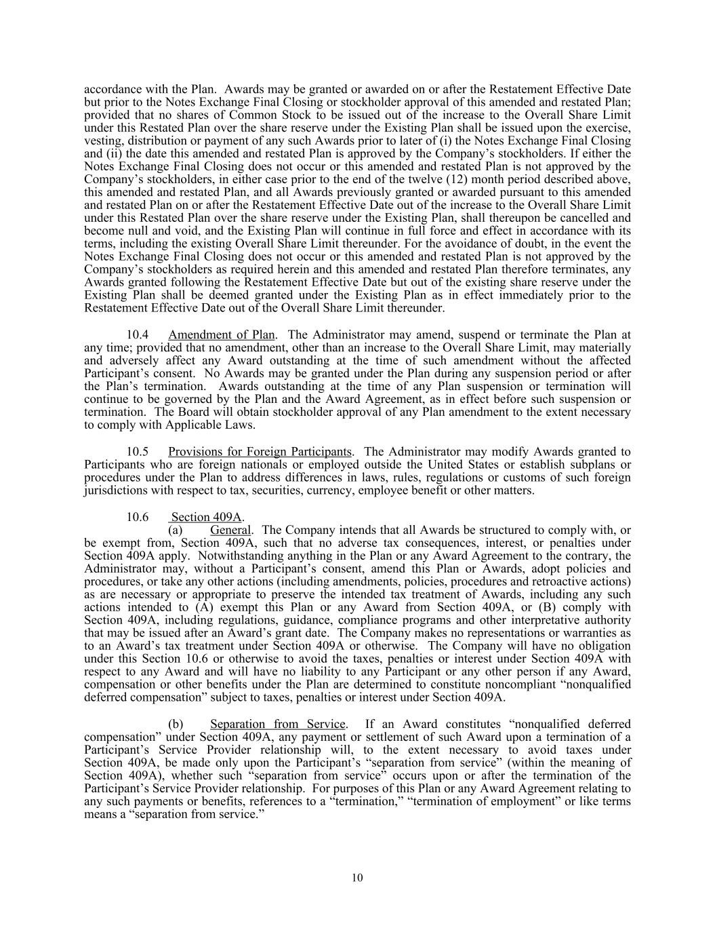
accordance with the Plan. Awards may be granted or awarded on or after the Restatement Effective Date but prior to the Notes Exchange Final Closing or stockholder approval of this amended and restated Plan; provided that no shares of Common Stock to be issued out of the increase to the Overall Share Limit under this Restated Plan over the share reserve under the Existing Plan shall be issued upon the exercise, vesting, distribution or payment of any such Awards prior to later of (i) the Notes Exchange Final Closing and (ii) the date this amended and restated Plan is approved by the Company’s stockholders. If either the Notes Exchange Final Closing does not occur or this amended and restated Plan is not approved by the Company’s stockholders, in either case prior to the end of the twelve (12) month period described above, this amended and restated Plan, and all Awards previously granted or awarded pursuant to this amended and restated Plan on or after the Restatement Effective Date out of the increase to the Overall Share Limit under this Restated Plan over the share reserve under the Existing Plan, shall thereupon be cancelled and become null and void, and the Existing Plan will continue in full force and effect in accordance with its terms, including the existing Overall Share Limit thereunder. For the avoidance of doubt, in the event the Notes Exchange Final Closing does not occur or this amended and restated Plan is not approved by the Company’s stockholders as required herein and this amended and restated Plan therefore terminates, any Awards granted following the Restatement Effective Date but out of the existing share reserve under the Existing Plan shall be deemed granted under the Existing Plan as in effect immediately prior to the Restatement Effective Date out of the Overall Share Limit thereunder. 10.4 Amendment of Plan. The Administrator may amend, suspend or terminate the Plan at any time; provided that no amendment, other than an increase to the Overall Share Limit, may materially and adversely affect any Award outstanding at the time of such amendment without the affected Participant’s consent. No Awards may be granted under the Plan during any suspension period or after the Plan’s termination. Awards outstanding at the time of any Plan suspension or termination will continue to be governed by the Plan and the Award Agreement, as in effect before such suspension or termination. The Board will obtain stockholder approval of any Plan amendment to the extent necessary to comply with Applicable Laws. 10.5 Provisions for Foreign Participants. The Administrator may modify Awards granted to Participants who are foreign nationals or employed outside the United States or establish subplans or procedures under the Plan to address differences in laws, rules, regulations or customs of such foreign jurisdictions with respect to tax, securities, currency, employee benefit or other matters. 10.6 Section 409A. (a) General. The Company intends that all Awards be structured to comply with, or be exempt from, Section 409A, such that no adverse tax consequences, interest, or penalties under Section 409A apply. Notwithstanding anything in the Plan or any Award Agreement to the contrary, the Administrator may, without a Participant’s consent, amend this Plan or Awards, adopt policies and procedures, or take any other actions (including amendments, policies, procedures and retroactive actions) as are necessary or appropriate to preserve the intended tax treatment of Awards, including any such actions intended to (A) exempt this Plan or any Award from Section 409A, or (B) comply with Section 409A, including regulations, guidance, compliance programs and other interpretative authority that may be issued after an Award’s grant date. The Company makes no representations or warranties as to an Award’s tax treatment under Section 409A or otherwise. The Company will have no obligation under this Section 10.6 or otherwise to avoid the taxes, penalties or interest under Section 409A with respect to any Award and will have no liability to any Participant or any other person if any Award, compensation or other benefits under the Plan are determined to constitute noncompliant “nonqualified deferred compensation” subject to taxes, penalties or interest under Section 409A. (b) Separation from Service. If an Award constitutes “nonqualified deferred compensation” under Section 409A, any payment or settlement of such Award upon a termination of a Participant’s Service Provider relationship will, to the extent necessary to avoid taxes under Section 409A, be made only upon the Participant’s “separation from service” (within the meaning of Section 409A), whether such “separation from service” occurs upon or after the termination of the Participant’s Service Provider relationship. For purposes of this Plan or any Award Agreement relating to any such payments or benefits, references to a “termination,” “termination of employment” or like terms means a “separation from service.” 10

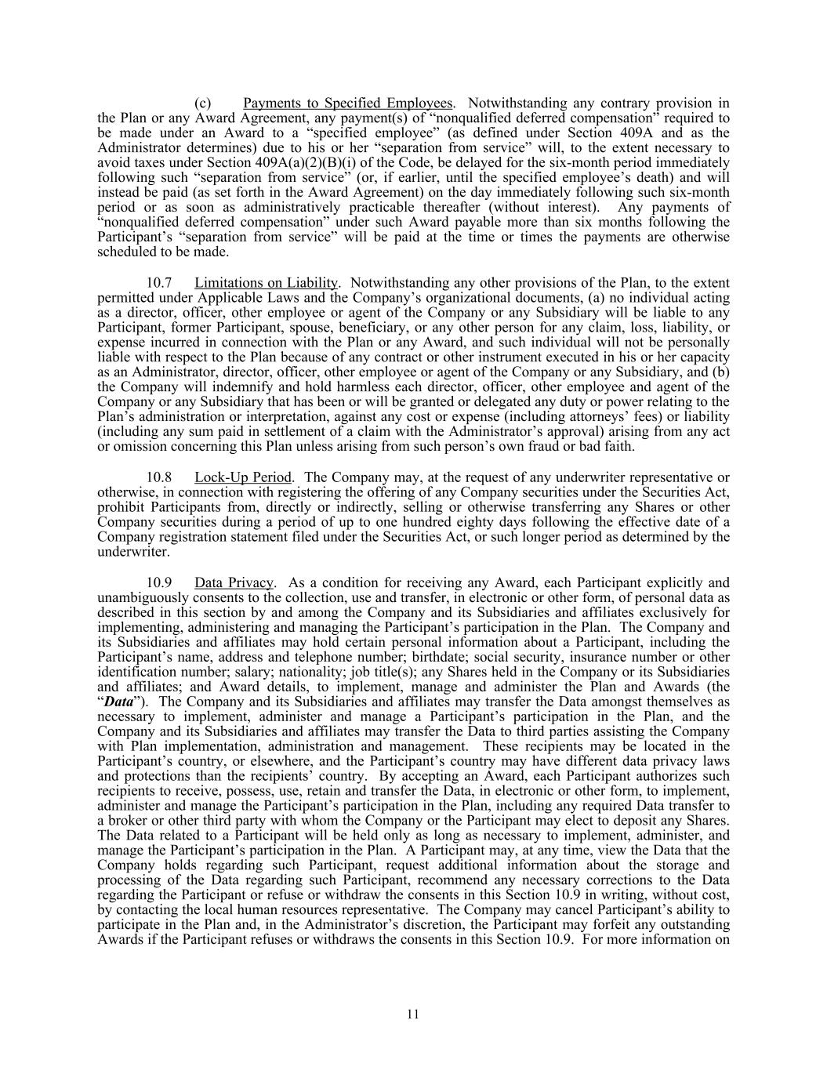
(c) Payments to Specified Employees. Notwithstanding any contrary provision in the Plan or any Award Agreement, any payment(s) of “nonqualified deferred compensation” required to be made under an Award to a “specified employee” (as defined under Section 409A and as the Administrator determines) due to his or her “separation from service” will, to the extent necessary to avoid taxes under Section 409A(a)(2)(B)(i) of the Code, be delayed for the six-month period immediately following such “separation from service” (or, if earlier, until the specified employee’s death) and will instead be paid (as set forth in the Award Agreement) on the day immediately following such six-month period or as soon as administratively practicable thereafter (without interest). Any payments of “nonqualified deferred compensation” under such Award payable more than six months following the Participant’s “separation from service” will be paid at the time or times the payments are otherwise scheduled to be made. 10.7 Limitations on Liability. Notwithstanding any other provisions of the Plan, to the extent permitted under Applicable Laws and the Company’s organizational documents, (a) no individual acting as a director, officer, other employee or agent of the Company or any Subsidiary will be liable to any Participant, former Participant, spouse, beneficiary, or any other person for any claim, loss, liability, or expense incurred in connection with the Plan or any Award, and such individual will not be personally liable with respect to the Plan because of any contract or other instrument executed in his or her capacity as an Administrator, director, officer, other employee or agent of the Company or any Subsidiary, and (b) the Company will indemnify and hold harmless each director, officer, other employee and agent of the Company or any Subsidiary that has been or will be granted or delegated any duty or power relating to the Plan’s administration or interpretation, against any cost or expense (including attorneys’ fees) or liability (including any sum paid in settlement of a claim with the Administrator’s approval) arising from any act or omission concerning this Plan unless arising from such person’s own fraud or bad faith. 10.8 Lock-Up Period. The Company may, at the request of any underwriter representative or otherwise, in connection with registering the offering of any Company securities under the Securities Act, prohibit Participants from, directly or indirectly, selling or otherwise transferring any Shares or other Company securities during a period of up to one hundred eighty days following the effective date of a Company registration statement filed under the Securities Act, or such longer period as determined by the underwriter. 10.9 Data Privacy. As a condition for receiving any Award, each Participant explicitly and unambiguously consents to the collection, use and transfer, in electronic or other form, of personal data as described in this section by and among the Company and its Subsidiaries and affiliates exclusively for implementing, administering and managing the Participant’s participation in the Plan. The Company and its Subsidiaries and affiliates may hold certain personal information about a Participant, including the Participant’s name, address and telephone number; birthdate; social security, insurance number or other identification number; salary; nationality; job title(s); any Shares held in the Company or its Subsidiaries and affiliates; and Award details, to implement, manage and administer the Plan and Awards (the “Data”). The Company and its Subsidiaries and affiliates may transfer the Data amongst themselves as necessary to implement, administer and manage a Participant’s participation in the Plan, and the Company and its Subsidiaries and affiliates may transfer the Data to third parties assisting the Company with Plan implementation, administration and management. These recipients may be located in the Participant’s country, or elsewhere, and the Participant’s country may have different data privacy laws and protections than the recipients’ country. By accepting an Award, each Participant authorizes such recipients to receive, possess, use, retain and transfer the Data, in electronic or other form, to implement, administer and manage the Participant’s participation in the Plan, including any required Data transfer to a broker or other third party with whom the Company or the Participant may elect to deposit any Shares. The Data related to a Participant will be held only as long as necessary to implement, administer, and manage the Participant’s participation in the Plan. A Participant may, at any time, view the Data that the Company holds regarding such Participant, request additional information about the storage and processing of the Data regarding such Participant, recommend any necessary corrections to the Data regarding the Participant or refuse or withdraw the consents in this Section 10.9 in writing, without cost, by contacting the local human resources representative. The Company may cancel Participant’s ability to participate in the Plan and, in the Administrator’s discretion, the Participant may forfeit any outstanding Awards if the Participant refuses or withdraws the consents in this Section 10.9. For more information on 11

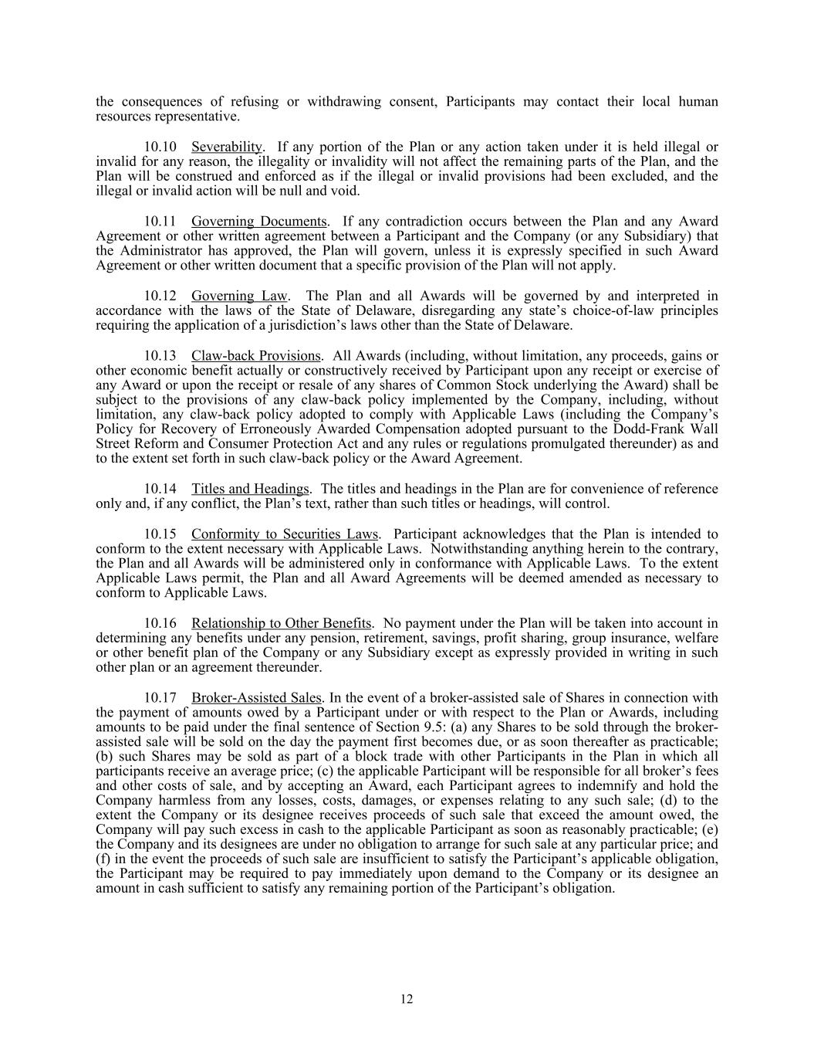
the consequences of refusing or withdrawing consent, Participants may contact their local human resources representative. 10.10 Severability. If any portion of the Plan or any action taken under it is held illegal or invalid for any reason, the illegality or invalidity will not affect the remaining parts of the Plan, and the Plan will be construed and enforced as if the illegal or invalid provisions had been excluded, and the illegal or invalid action will be null and void. 10.11 Governing Documents. If any contradiction occurs between the Plan and any Award Agreement or other written agreement between a Participant and the Company (or any Subsidiary) that the Administrator has approved, the Plan will govern, unless it is expressly specified in such Award Agreement or other written document that a specific provision of the Plan will not apply. 10.12 Governing Law. The Plan and all Awards will be governed by and interpreted in accordance with the laws of the State of Delaware, disregarding any state’s choice-of-law principles requiring the application of a jurisdiction’s laws other than the State of Delaware. 10.13 Claw-back Provisions. All Awards (including, without limitation, any proceeds, gains or other economic benefit actually or constructively received by Participant upon any receipt or exercise of any Award or upon the receipt or resale of any shares of Common Stock underlying the Award) shall be subject to the provisions of any claw-back policy implemented by the Company, including, without limitation, any claw-back policy adopted to comply with Applicable Laws (including the Company’s Policy for Recovery of Erroneously Awarded Compensation adopted pursuant to the Dodd-Frank Wall Street Reform and Consumer Protection Act and any rules or regulations promulgated thereunder) as and to the extent set forth in such claw-back policy or the Award Agreement. 10.14 Titles and Headings. The titles and headings in the Plan are for convenience of reference only and, if any conflict, the Plan’s text, rather than such titles or headings, will control. 10.15 Conformity to Securities Laws. Participant acknowledges that the Plan is intended to conform to the extent necessary with Applicable Laws. Notwithstanding anything herein to the contrary, the Plan and all Awards will be administered only in conformance with Applicable Laws. To the extent Applicable Laws permit, the Plan and all Award Agreements will be deemed amended as necessary to conform to Applicable Laws. 10.16 Relationship to Other Benefits. No payment under the Plan will be taken into account in determining any benefits under any pension, retirement, savings, profit sharing, group insurance, welfare or other benefit plan of the Company or any Subsidiary except as expressly provided in writing in such other plan or an agreement thereunder. 10.17 Broker-Assisted Sales. In the event of a broker-assisted sale of Shares in connection with the payment of amounts owed by a Participant under or with respect to the Plan or Awards, including amounts to be paid under the final sentence of Section 9.5: (a) any Shares to be sold through the broker- assisted sale will be sold on the day the payment first becomes due, or as soon thereafter as practicable; (b) such Shares may be sold as part of a block trade with other Participants in the Plan in which all participants receive an average price; (c) the applicable Participant will be responsible for all broker’s fees and other costs of sale, and by accepting an Award, each Participant agrees to indemnify and hold the Company harmless from any losses, costs, damages, or expenses relating to any such sale; (d) to the extent the Company or its designee receives proceeds of such sale that exceed the amount owed, the Company will pay such excess in cash to the applicable Participant as soon as reasonably practicable; (e) the Company and its designees are under no obligation to arrange for such sale at any particular price; and (f) in the event the proceeds of such sale are insufficient to satisfy the Participant’s applicable obligation, the Participant may be required to pay immediately upon demand to the Company or its designee an amount in cash sufficient to satisfy any remaining portion of the Participant’s obligation. 12

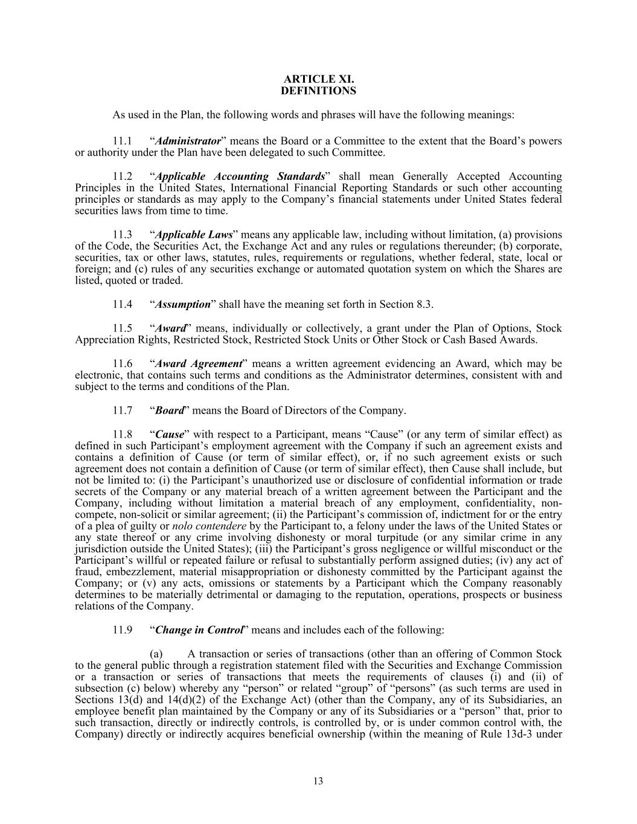
ARTICLE XI. DEFINITIONS As used in the Plan, the following words and phrases will have the following meanings: 11.1 “Administrator” means the Board or a Committee to the extent that the Board’s powers or authority under the Plan have been delegated to such Committee. 11.2 “Applicable Accounting Standards” shall mean Generally Accepted Accounting Principles in the United States, International Financial Reporting Standards or such other accounting principles or standards as may apply to the Company’s financial statements under United States federal securities laws from time to time. 11.3 “Applicable Laws” means any applicable law, including without limitation, (a) provisions of the Code, the Securities Act, the Exchange Act and any rules or regulations thereunder; (b) corporate, securities, tax or other laws, statutes, rules, requirements or regulations, whether federal, state, local or foreign; and (c) rules of any securities exchange or automated quotation system on which the Shares are listed, quoted or traded. 11.4 “Assumption” shall have the meaning set forth in Section 8.3. 11.5 “Award” means, individually or collectively, a grant under the Plan of Options, Stock Appreciation Rights, Restricted Stock, Restricted Stock Units or Other Stock or Cash Based Awards. 11.6 “Award Agreement” means a written agreement evidencing an Award, which may be electronic, that contains such terms and conditions as the Administrator determines, consistent with and subject to the terms and conditions of the Plan. 11.7 “Board” means the Board of Directors of the Company. 11.8 “Cause” with respect to a Participant, means “Cause” (or any term of similar effect) as defined in such Participant’s employment agreement with the Company if such an agreement exists and contains a definition of Cause (or term of similar effect), or, if no such agreement exists or such agreement does not contain a definition of Cause (or term of similar effect), then Cause shall include, but not be limited to: (i) the Participant’s unauthorized use or disclosure of confidential information or trade secrets of the Company or any material breach of a written agreement between the Participant and the Company, including without limitation a material breach of any employment, confidentiality, non- compete, non-solicit or similar agreement; (ii) the Participant’s commission of, indictment for or the entry of a plea of guilty or nolo contendere by the Participant to, a felony under the laws of the United States or any state thereof or any crime involving dishonesty or moral turpitude (or any similar crime in any jurisdiction outside the United States); (iii) the Participant’s gross negligence or willful misconduct or the Participant’s willful or repeated failure or refusal to substantially perform assigned duties; (iv) any act of fraud, embezzlement, material misappropriation or dishonesty committed by the Participant against the Company; or (v) any acts, omissions or statements by a Participant which the Company reasonably determines to be materially detrimental or damaging to the reputation, operations, prospects or business relations of the Company. 11.9 “Change in Control” means and includes each of the following: (a) A transaction or series of transactions (other than an offering of Common Stock to the general public through a registration statement filed with the Securities and Exchange Commission or a transaction or series of transactions that meets the requirements of clauses (i) and (ii) of subsection (c) below) whereby any “person” or related “group” of “persons” (as such terms are used in Sections 13(d) and 14(d)(2) of the Exchange Act) (other than the Company, any of its Subsidiaries, an employee benefit plan maintained by the Company or any of its Subsidiaries or a “person” that, prior to such transaction, directly or indirectly controls, is controlled by, or is under common control with, the Company) directly or indirectly acquires beneficial ownership (within the meaning of Rule 13d-3 under 13

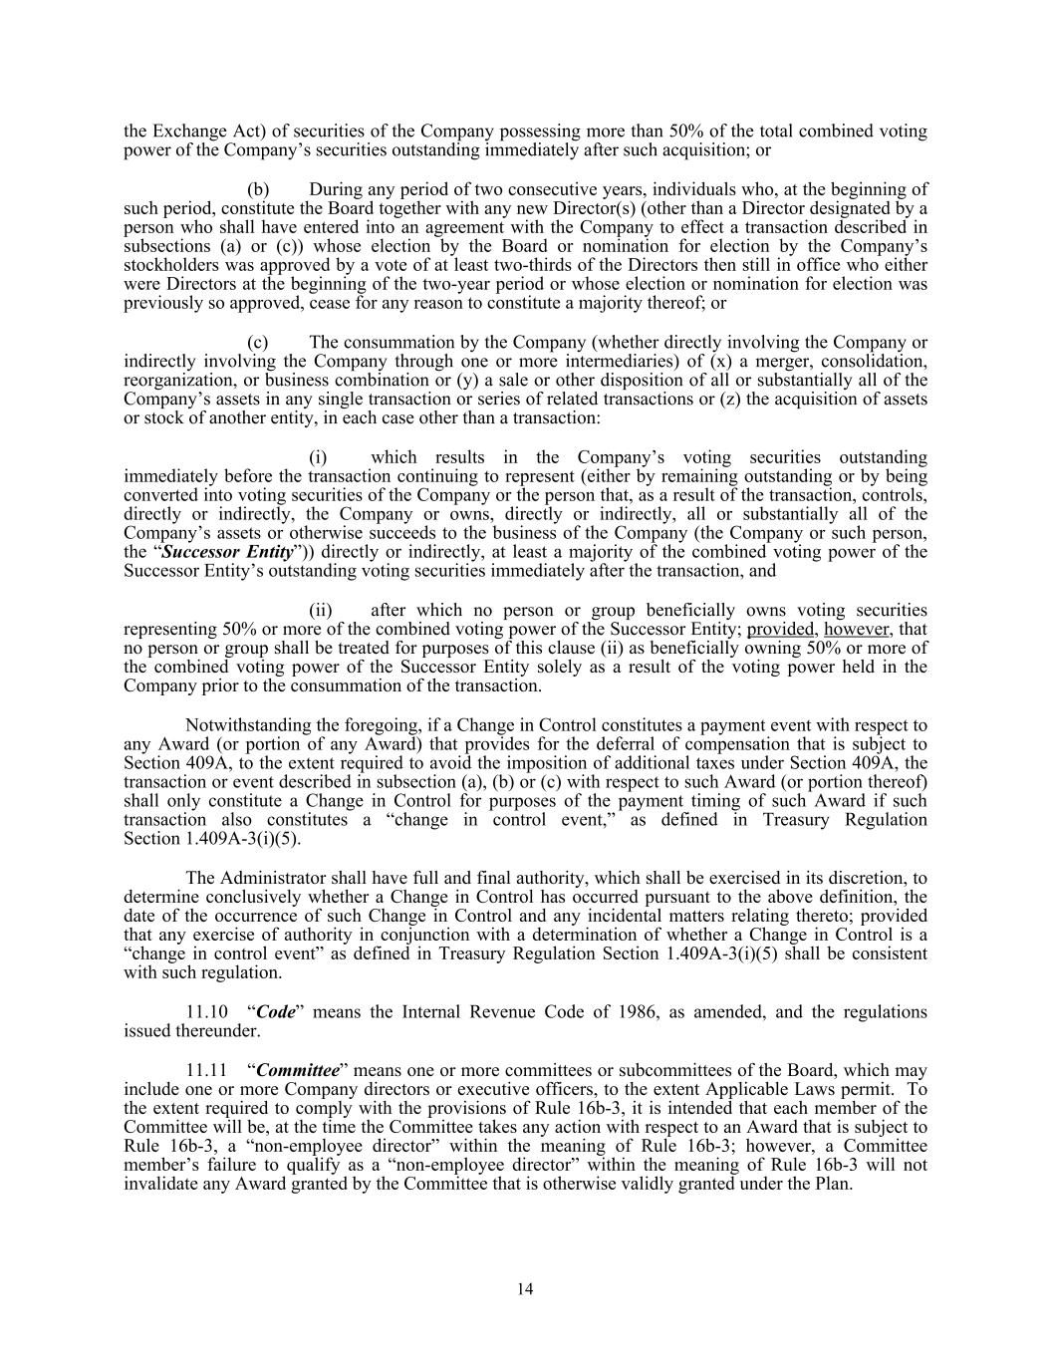
the Exchange Act) of securities of the Company possessing more than 50% of the total combined voting power of the Company’s securities outstanding immediately after such acquisition; or (b) During any period of two consecutive years, individuals who, at the beginning of such period, constitute the Board together with any new Director(s) (other than a Director designated by a person who shall have entered into an agreement with the Company to effect a transaction described in subsections (a) or (c)) whose election by the Board or nomination for election by the Company’s stockholders was approved by a vote of at least two-thirds of the Directors then still in office who either were Directors at the beginning of the two-year period or whose election or nomination for election was previously so approved, cease for any reason to constitute a majority thereof; or (c) The consummation by the Company (whether directly involving the Company or indirectly involving the Company through one or more intermediaries) of (x) a merger, consolidation, reorganization, or business combination or (y) a sale or other disposition of all or substantially all of the Company’s assets in any single transaction or series of related transactions or (z) the acquisition of assets or stock of another entity, in each case other than a transaction: (i) which results in the Company’s voting securities outstanding immediately before the transaction continuing to represent (either by remaining outstanding or by being converted into voting securities of the Company or the person that, as a result of the transaction, controls, directly or indirectly, the Company or owns, directly or indirectly, all or substantially all of the Company’s assets or otherwise succeeds to the business of the Company (the Company or such person, the “Successor Entity”)) directly or indirectly, at least a majority of the combined voting power of the Successor Entity’s outstanding voting securities immediately after the transaction, and (ii) after which no person or group beneficially owns voting securities representing 50% or more of the combined voting power of the Successor Entity; provided, however, that no person or group shall be treated for purposes of this clause (ii) as beneficially owning 50% or more of the combined voting power of the Successor Entity solely as a result of the voting power held in the Company prior to the consummation of the transaction. Notwithstanding the foregoing, if a Change in Control constitutes a payment event with respect to any Award (or portion of any Award) that provides for the deferral of compensation that is subject to Section 409A, to the extent required to avoid the imposition of additional taxes under Section 409A, the transaction or event described in subsection (a), (b) or (c) with respect to such Award (or portion thereof) shall only constitute a Change in Control for purposes of the payment timing of such Award if such transaction also constitutes a “change in control event,” as defined in Treasury Regulation Section 1.409A-3(i)(5). The Administrator shall have full and final authority, which shall be exercised in its discretion, to determine conclusively whether a Change in Control has occurred pursuant to the above definition, the date of the occurrence of such Change in Control and any incidental matters relating thereto; provided that any exercise of authority in conjunction with a determination of whether a Change in Control is a “change in control event” as defined in Treasury Regulation Section 1.409A-3(i)(5) shall be consistent with such regulation. 11.10 “Code” means the Internal Revenue Code of 1986, as amended, and the regulations issued thereunder. 11.11 “Committee” means one or more committees or subcommittees of the Board, which may include one or more Company directors or executive officers, to the extent Applicable Laws permit. To the extent required to comply with the provisions of Rule 16b-3, it is intended that each member of the Committee will be, at the time the Committee takes any action with respect to an Award that is subject to Rule 16b-3, a “non-employee director” within the meaning of Rule 16b-3; however, a Committee member’s failure to qualify as a “non-employee director” within the meaning of Rule 16b-3 will not invalidate any Award granted by the Committee that is otherwise validly granted under the Plan. 14

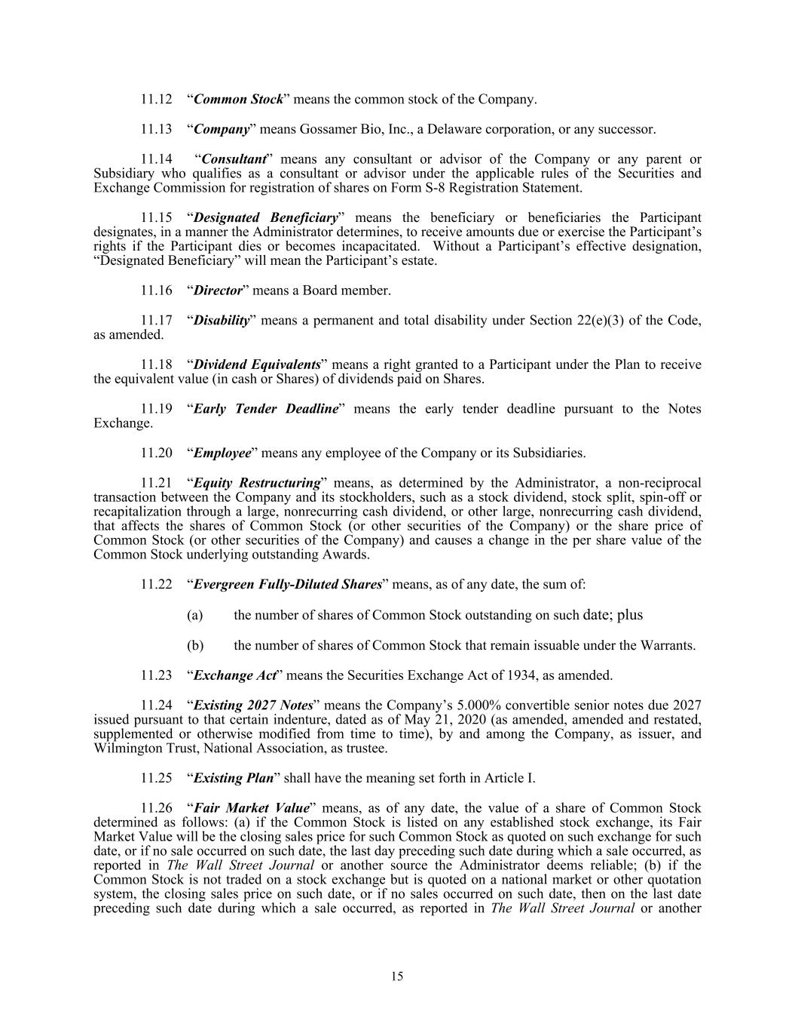
11.12 “Common Stock” means the common stock of the Company. 11.13 “Company” means Gossamer Bio, Inc., a Delaware corporation, or any successor. 11.14 “Consultant” means any consultant or advisor of the Company or any parent or Subsidiary who qualifies as a consultant or advisor under the applicable rules of the Securities and Exchange Commission for registration of shares on Form S-8 Registration Statement. 11.15 “Designated Beneficiary” means the beneficiary or beneficiaries the Participant designates, in a manner the Administrator determines, to receive amounts due or exercise the Participant’s rights if the Participant dies or becomes incapacitated. Without a Participant’s effective designation, “Designated Beneficiary” will mean the Participant’s estate. 11.16 “Director” means a Board member. 11.17 “Disability” means a permanent and total disability under Section 22(e)(3) of the Code, as amended. 11.18 “Dividend Equivalents” means a right granted to a Participant under the Plan to receive the equivalent value (in cash or Shares) of dividends paid on Shares. 11.19 “Early Tender Deadline” means the early tender deadline pursuant to the Notes Exchange. 11.20 “Employee” means any employee of the Company or its Subsidiaries. 11.21 “Equity Restructuring” means, as determined by the Administrator, a non-reciprocal transaction between the Company and its stockholders, such as a stock dividend, stock split, spin-off or recapitalization through a large, nonrecurring cash dividend, or other large, nonrecurring cash dividend, that affects the shares of Common Stock (or other securities of the Company) or the share price of Common Stock (or other securities of the Company) and causes a change in the per share value of the Common Stock underlying outstanding Awards. 11.22 “Evergreen Fully-Diluted Shares” means, as of any date, the sum of: (a) the number of shares of Common Stock outstanding on such date; plus (b) the number of shares of Common Stock that remain issuable under the Warrants. 11.23 “Exchange Act” means the Securities Exchange Act of 1934, as amended. 11.24 “Existing 2027 Notes” means the Company’s 5.000% convertible senior notes due 2027 issued pursuant to that certain indenture, dated as of May 21, 2020 (as amended, amended and restated, supplemented or otherwise modified from time to time), by and among the Company, as issuer, and Wilmington Trust, National Association, as trustee. 11.25 “Existing Plan” shall have the meaning set forth in Article I. 11.26 “Fair Market Value” means, as of any date, the value of a share of Common Stock determined as follows: (a) if the Common Stock is listed on any established stock exchange, its Fair Market Value will be the closing sales price for such Common Stock as quoted on such exchange for such date, or if no sale occurred on such date, the last day preceding such date during which a sale occurred, as reported in The Wall Street Journal or another source the Administrator deems reliable; (b) if the Common Stock is not traded on a stock exchange but is quoted on a national market or other quotation system, the closing sales price on such date, or if no sales occurred on such date, then on the last date preceding such date during which a sale occurred, as reported in The Wall Street Journal or another 15

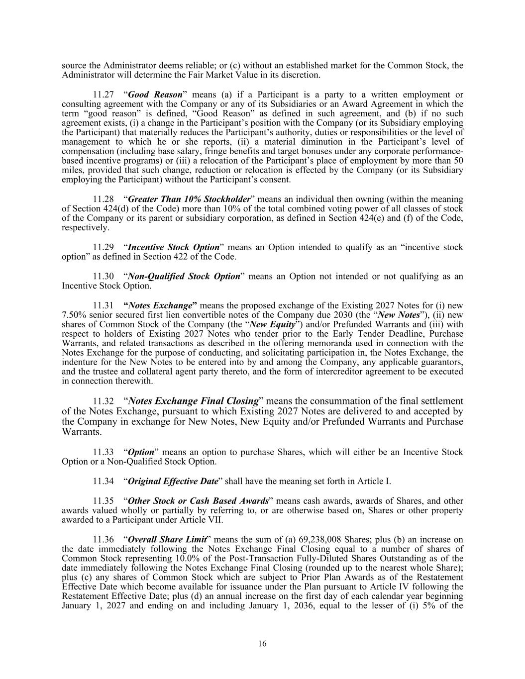
source the Administrator deems reliable; or (c) without an established market for the Common Stock, the Administrator will determine the Fair Market Value in its discretion. 11.27 “Good Reason” means (a) if a Participant is a party to a written employment or consulting agreement with the Company or any of its Subsidiaries or an Award Agreement in which the term “good reason” is defined, “Good Reason” as defined in such agreement, and (b) if no such agreement exists, (i) a change in the Participant’s position with the Company (or its Subsidiary employing the Participant) that materially reduces the Participant’s authority, duties or responsibilities or the level of management to which he or she reports, (ii) a material diminution in the Participant’s level of compensation (including base salary, fringe benefits and target bonuses under any corporate performance- based incentive programs) or (iii) a relocation of the Participant’s place of employment by more than 50 miles, provided that such change, reduction or relocation is effected by the Company (or its Subsidiary employing the Participant) without the Participant’s consent. 11.28 “Greater Than 10% Stockholder” means an individual then owning (within the meaning of Section 424(d) of the Code) more than 10% of the total combined voting power of all classes of stock of the Company or its parent or subsidiary corporation, as defined in Section 424(e) and (f) of the Code, respectively. 11.29 “Incentive Stock Option” means an Option intended to qualify as an “incentive stock option” as defined in Section 422 of the Code. 11.30 “Non-Qualified Stock Option” means an Option not intended or not qualifying as an Incentive Stock Option. 11.31 “Notes Exchange” means the proposed exchange of the Existing 2027 Notes for (i) new 7.50% senior secured first lien convertible notes of the Company due 2030 (the “New Notes”), (ii) new shares of Common Stock of the Company (the “New Equity”) and/or Prefunded Warrants and (iii) with respect to holders of Existing 2027 Notes who tender prior to the Early Tender Deadline, Purchase Warrants, and related transactions as described in the offering memoranda used in connection with the Notes Exchange for the purpose of conducting, and solicitating participation in, the Notes Exchange, the indenture for the New Notes to be entered into by and among the Company, any applicable guarantors, and the trustee and collateral agent party thereto, and the form of intercreditor agreement to be executed in connection therewith. 11.32 “Notes Exchange Final Closing” means the consummation of the final settlement of the Notes Exchange, pursuant to which Existing 2027 Notes are delivered to and accepted by the Company in exchange for New Notes, New Equity and/or Prefunded Warrants and Purchase Warrants. 11.33 “Option” means an option to purchase Shares, which will either be an Incentive Stock Option or a Non-Qualified Stock Option. 11.34 “Original Effective Date” shall have the meaning set forth in Article I. 11.35 “Other Stock or Cash Based Awards” means cash awards, awards of Shares, and other awards valued wholly or partially by referring to, or are otherwise based on, Shares or other property awarded to a Participant under Article VII. 11.36 “Overall Share Limit” means the sum of (a) 69,238,008 Shares; plus (b) an increase on the date immediately following the Notes Exchange Final Closing equal to a number of shares of Common Stock representing 10.0% of the Post-Transaction Fully-Diluted Shares Outstanding as of the date immediately following the Notes Exchange Final Closing (rounded up to the nearest whole Share); plus (c) any shares of Common Stock which are subject to Prior Plan Awards as of the Restatement Effective Date which become available for issuance under the Plan pursuant to Article IV following the Restatement Effective Date; plus (d) an annual increase on the first day of each calendar year beginning January 1, 2027 and ending on and including January 1, 2036, equal to the lesser of (i) 5% of the 16

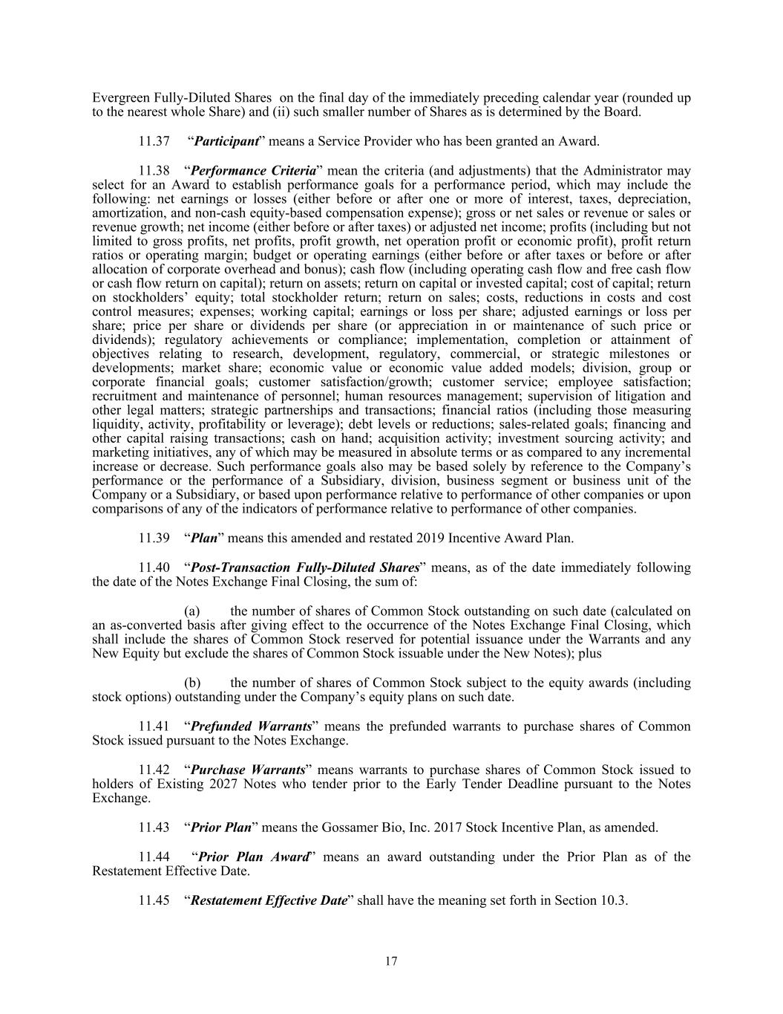
Evergreen Fully-Diluted Shares on the final day of the immediately preceding calendar year (rounded up to the nearest whole Share) and (ii) such smaller number of Shares as is determined by the Board. 11.37 “Participant” means a Service Provider who has been granted an Award. 11.38 “Performance Criteria” mean the criteria (and adjustments) that the Administrator may select for an Award to establish performance goals for a performance period, which may include the following: net earnings or losses (either before or after one or more of interest, taxes, depreciation, amortization, and non-cash equity-based compensation expense); gross or net sales or revenue or sales or revenue growth; net income (either before or after taxes) or adjusted net income; profits (including but not limited to gross profits, net profits, profit growth, net operation profit or economic profit), profit return ratios or operating margin; budget or operating earnings (either before or after taxes or before or after allocation of corporate overhead and bonus); cash flow (including operating cash flow and free cash flow or cash flow return on capital); return on assets; return on capital or invested capital; cost of capital; return on stockholders’ equity; total stockholder return; return on sales; costs, reductions in costs and cost control measures; expenses; working capital; earnings or loss per share; adjusted earnings or loss per share; price per share or dividends per share (or appreciation in or maintenance of such price or dividends); regulatory achievements or compliance; implementation, completion or attainment of objectives relating to research, development, regulatory, commercial, or strategic milestones or developments; market share; economic value or economic value added models; division, group or corporate financial goals; customer satisfaction/growth; customer service; employee satisfaction; recruitment and maintenance of personnel; human resources management; supervision of litigation and other legal matters; strategic partnerships and transactions; financial ratios (including those measuring liquidity, activity, profitability or leverage); debt levels or reductions; sales-related goals; financing and other capital raising transactions; cash on hand; acquisition activity; investment sourcing activity; and marketing initiatives, any of which may be measured in absolute terms or as compared to any incremental increase or decrease. Such performance goals also may be based solely by reference to the Company’s performance or the performance of a Subsidiary, division, business segment or business unit of the Company or a Subsidiary, or based upon performance relative to performance of other companies or upon comparisons of any of the indicators of performance relative to performance of other companies. 11.39 “Plan” means this amended and restated 2019 Incentive Award Plan. 11.40 “Post-Transaction Fully-Diluted Shares” means, as of the date immediately following the date of the Notes Exchange Final Closing, the sum of: (a) the number of shares of Common Stock outstanding on such date (calculated on an as-converted basis after giving effect to the occurrence of the Notes Exchange Final Closing, which shall include the shares of Common Stock reserved for potential issuance under the Warrants and any New Equity but exclude the shares of Common Stock issuable under the New Notes); plus (b) the number of shares of Common Stock subject to the equity awards (including stock options) outstanding under the Company’s equity plans on such date. 11.41 “Prefunded Warrants” means the prefunded warrants to purchase shares of Common Stock issued pursuant to the Notes Exchange. 11.42 “Purchase Warrants” means warrants to purchase shares of Common Stock issued to holders of Existing 2027 Notes who tender prior to the Early Tender Deadline pursuant to the Notes Exchange. 11.43 “Prior Plan” means the Gossamer Bio, Inc. 2017 Stock Incentive Plan, as amended. 11.44 “Prior Plan Award” means an award outstanding under the Prior Plan as of the Restatement Effective Date. 11.45 “Restatement Effective Date” shall have the meaning set forth in Section 10.3. 17

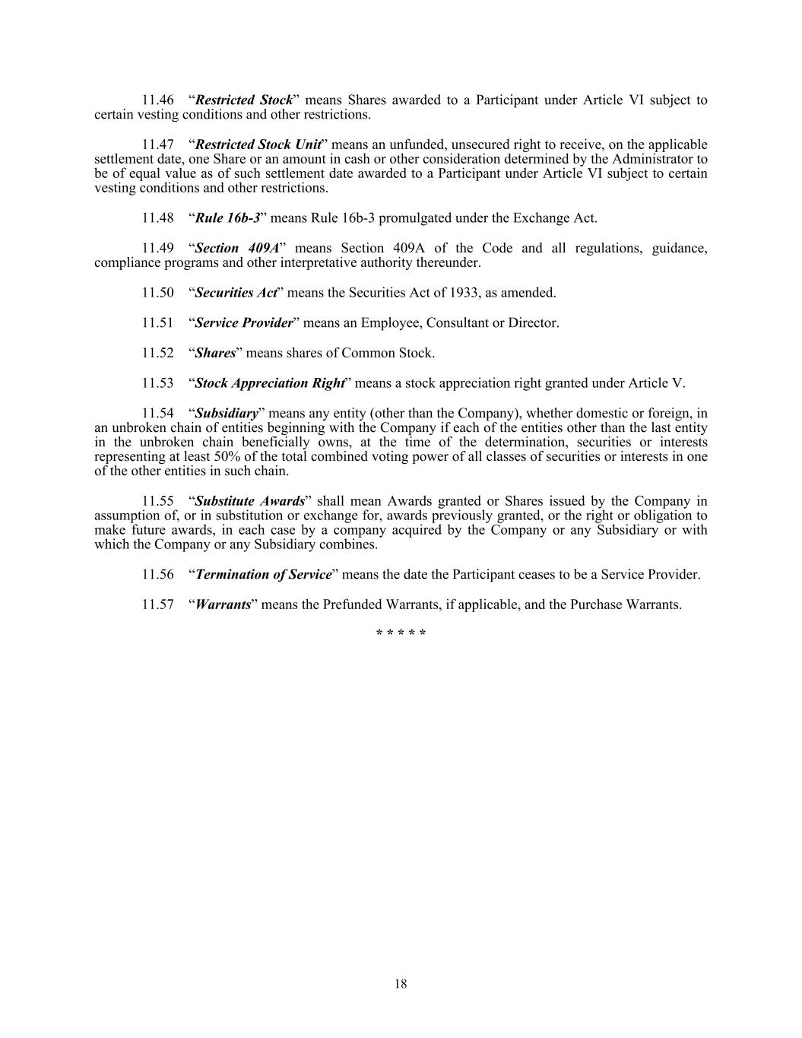
11.46 “Restricted Stock” means Shares awarded to a Participant under Article VI subject to certain vesting conditions and other restrictions. 11.47 “Restricted Stock Unit” means an unfunded, unsecured right to receive, on the applicable settlement date, one Share or an amount in cash or other consideration determined by the Administrator to be of equal value as of such settlement date awarded to a Participant under Article VI subject to certain vesting conditions and other restrictions. 11.48 “Rule 16b-3” means Rule 16b-3 promulgated under the Exchange Act. 11.49 “Section 409A” means Section 409A of the Code and all regulations, guidance, compliance programs and other interpretative authority thereunder. 11.50 “Securities Act” means the Securities Act of 1933, as amended. 11.51 “Service Provider” means an Employee, Consultant or Director. 11.52 “Shares” means shares of Common Stock. 11.53 “Stock Appreciation Right” means a stock appreciation right granted under Article V. 11.54 “Subsidiary” means any entity (other than the Company), whether domestic or foreign, in an unbroken chain of entities beginning with the Company if each of the entities other than the last entity in the unbroken chain beneficially owns, at the time of the determination, securities or interests representing at least 50% of the total combined voting power of all classes of securities or interests in one of the other entities in such chain. 11.55 “Substitute Awards” shall mean Awards granted or Shares issued by the Company in assumption of, or in substitution or exchange for, awards previously granted, or the right or obligation to make future awards, in each case by a company acquired by the Company or any Subsidiary or with which the Company or any Subsidiary combines. 11.56 “Termination of Service” means the date the Participant ceases to be a Service Provider. 11.57 “Warrants” means the Prefunded Warrants, if applicable, and the Purchase Warrants. * * * * * 18

