SEC Form 3
FORM 3 | UNITED STATES SECURITIES AND EXCHANGE COMMISSION  Washington, D.C. 20549  INITIAL STATEMENT OF BENEFICIAL OWNERSHIP OF SECURITIES  Filed pursuant to Section 16(a) of the Securities Exchange Act of 1934  or Section 30(h) of the Investment Company Act of 1940
  OMB APPROVAL
  OMB Number: | 3235-0104
  Estimated average burden
  hours per response: | 0.5
1. Name and Address of Reporting Person*  (Street) | 2. Date of Event Requiring Statement (Month/Day/Year)  09/16/2026 | 3. Issuer Name and Ticker or Trading Symbol  Gossamer Bio, Inc. [ GOSS ]  Foreign Trading Symbol
  Ciongoli Gregory Austin
  (Last) | (First) | (Middle)
  3115 MERRYFIELD ROW, SUITE 120
  SAN DIEGO | CA | 92121
  (City) | (State) | (Zip)
 |  | 4. Relationship of Reporting Person(s) to Issuer  (Check all applicable) | 5. If Amendment, Date of Original Filed (Month/Day/Year)
   | Director |  | 10% Owner
   | Officer (give title below) |  | Other (specify below)
6. Individual or Joint/Group Filing (Check Applicable Line)
Form filed by One Reporting Person
Form filed by More than One Reporting Person

Table I - Non-Derivative Securities Beneficially Owned
1. Title of Security (Instr. 4) | 2. Amount of Securities Beneficially Owned (Instr. 4) | 3. Ownership Form: Direct (D) or Indirect (I) (Instr. 5) | 4. Nature of Indirect Beneficial Ownership (Instr. 5)
Table II - Derivative Securities Beneficially Owned
(e.g., puts, calls, warrants, options, convertible securities)
1. Title of Derivative Security (Instr. 4) | 2. Date Exercisable and Expiration Date (Month/Day/Year) |  | 3. Title and Amount of Securities Underlying Derivative Security (Instr. 4) |  | 4. Conversion or Exercise Price of Derivative Security | 5. Ownership Form: Direct (D) or Indirect (I) (Instr. 5) | 6. Nature of Indirect Beneficial Ownership (Instr. 5)
1. Title of Derivative Security (Instr. 4) | Date Exercisable | Expiration Date | Title | Amount or Number of Shares | 4. Conversion or Exercise Price of Derivative Security | 5. Ownership Form: Direct (D) or Indirect (I) (Instr. 5) | 6. Nature of Indirect Beneficial Ownership (Instr. 5)
Pre-Funded Warrant (Right to Buy) | 08/24/2026 | (1) | Series A-1 Preferred Stock(2) | 250(2) | 0.0001 | D
Explanation of Responses:
1. The Pre-Funded Warrant has no expiration date and is exercisable immediately. Prior to the Issuer obtaining stockholder approval under applicable Nasdaq rules and regulations in connection with the Issuer's private placement pursuant to which the Pre-Funded Warrants were issued ("Stockholder Approval"), the Pre-Funded Warrants are only exercisable for shares of Series A-1 non-voting convertible preferred stock. Following the Issuer's receipt of Stockholder Approval, the Pre-Funded Warrants are only exercisable for shares of the Issuer's common stock.
2. Each share of Series A-1 non-voting convertible preferred stock is convertible automatically upon receipt of Stockholder Approval into a number of shares of the Issuer's common stock equal to $1,000 divided by $11.20, pursuant to the terms of the Series A-1 Certificate of Designation and subject to applicable beneficial ownership limitations.
Remarks:
 | /s/ Christian Waage, Attorney-in-Fact | 09/22/2026
 | ** Signature of Reporting Person | Date
Reminder: Report on a separate line for each class of securities beneficially owned directly or indirectly.
* If the form is filed by more than one reporting person, see Instruction 5 (b)(v).
** Intentional misstatements or omissions of facts constitute Federal Criminal Violations See 18 U.S.C. 1001 and 15 U.S.C. 78ff(a).
Note: File three copies of this Form, one of which must be manually signed. If space is insufficient, see Instruction 6 for procedure.
Persons who respond to the collection of information contained in this form are not required to respond unless the form displays a currently valid OMB Number.
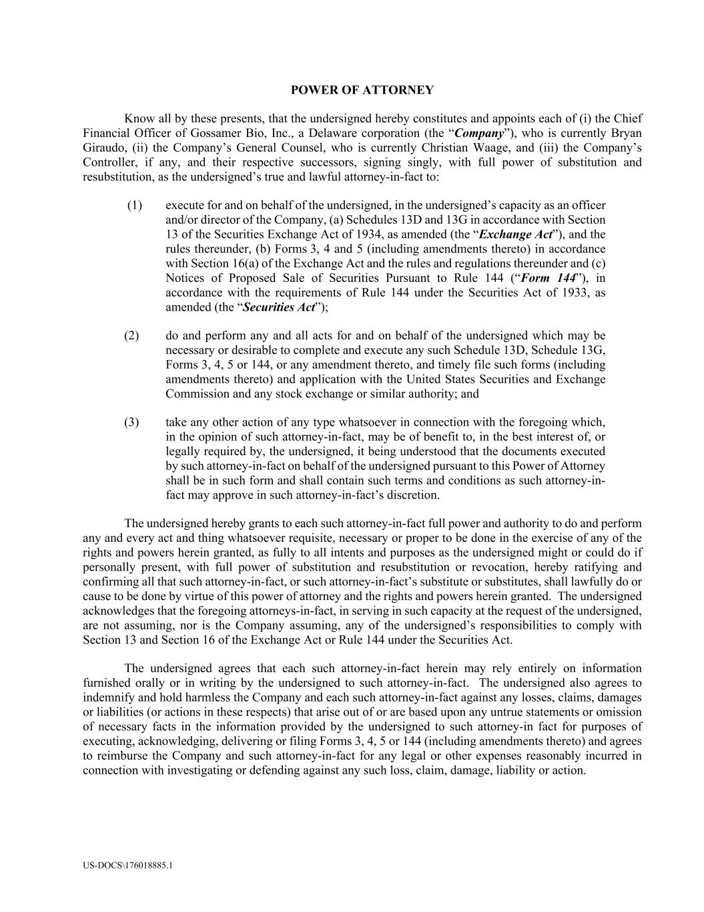
US-DOCS\176018885.1 POWER OF ATTORNEY Know all by these presents, that the undersigned hereby constitutes and appoints each of (i) the Chief Financial Officer of Gossamer Bio, Inc., a Delaware corporation (the “Company”), who is currently Bryan Giraudo, (ii) the Company’s General Counsel, who is currently Christian Waage, and (iii) the Company’s Controller, if any, and their respective successors, signing singly, with full power of substitution and resubstitution, as the undersigned’s true and lawful attorney-in-fact to: (1) execute for and on behalf of the undersigned, in the undersigned’s capacity as an officer and/or director of the Company, (a) Schedules 13D and 13G in accordance with Section 13 of the Securities Exchange Act of 1934, as amended (the “Exchange Act”), and the rules thereunder, (b) Forms 3, 4 and 5 (including amendments thereto) in accordance with Section 16(a) of the Exchange Act and the rules and regulations thereunder and (c) Notices of Proposed Sale of Securities Pursuant to Rule 144 (“Form 144”), in accordance with the requirements of Rule 144 under the Securities Act of 1933, as amended (the “Securities Act”); (2) do and perform any and all acts for and on behalf of the undersigned which may be necessary or desirable to complete and execute any such Schedule 13D, Schedule 13G, Forms 3, 4, 5 or 144, or any amendment thereto, and timely file such forms (including amendments thereto) and application with the United States Securities and Exchange Commission and any stock exchange or similar authority; and (3) take any other action of any type whatsoever in connection with the foregoing which, in the opinion of such attorney-in-fact, may be of benefit to, in the best interest of, or legally required by, the undersigned, it being understood that the documents executed by such attorney-in-fact on behalf of the undersigned pursuant to this Power of Attorney shall be in such form and shall contain such terms and conditions as such attorney-in- fact may approve in such attorney-in-fact’s discretion. The undersigned hereby grants to each such attorney-in-fact full power and authority to do and perform any and every act and thing whatsoever requisite, necessary or proper to be done in the exercise of any of the rights and powers herein granted, as fully to all intents and purposes as the undersigned might or could do if personally present, with full power of substitution and resubstitution or revocation, hereby ratifying and confirming all that such attorney-in-fact, or such attorney-in-fact’s substitute or substitutes, shall lawfully do or cause to be done by virtue of this power of attorney and the rights and powers herein granted. The undersigned acknowledges that the foregoing attorneys-in-fact, in serving in such capacity at the request of the undersigned, are not assuming, nor is the Company assuming, any of the undersigned’s responsibilities to comply with Section 13 and Section 16 of the Exchange Act or Rule 144 under the Securities Act. The undersigned agrees that each such attorney-in-fact herein may rely entirely on information furnished orally or in writing by the undersigned to such attorney-in-fact. The undersigned also agrees to indemnify and hold harmless the Company and each such attorney-in-fact against any losses, claims, damages or liabilities (or actions in these respects) that arise out of or are based upon any untrue statements or omission of necessary facts in the information provided by the undersigned to such attorney-in fact for purposes of executing, acknowledging, delivering or filing Forms 3, 4, 5 or 144 (including amendments thereto) and agrees to reimburse the Company and such attorney-in-fact for any legal or other expenses reasonably incurred in connection with investigating or defending against any such loss, claim, damage, liability or action.

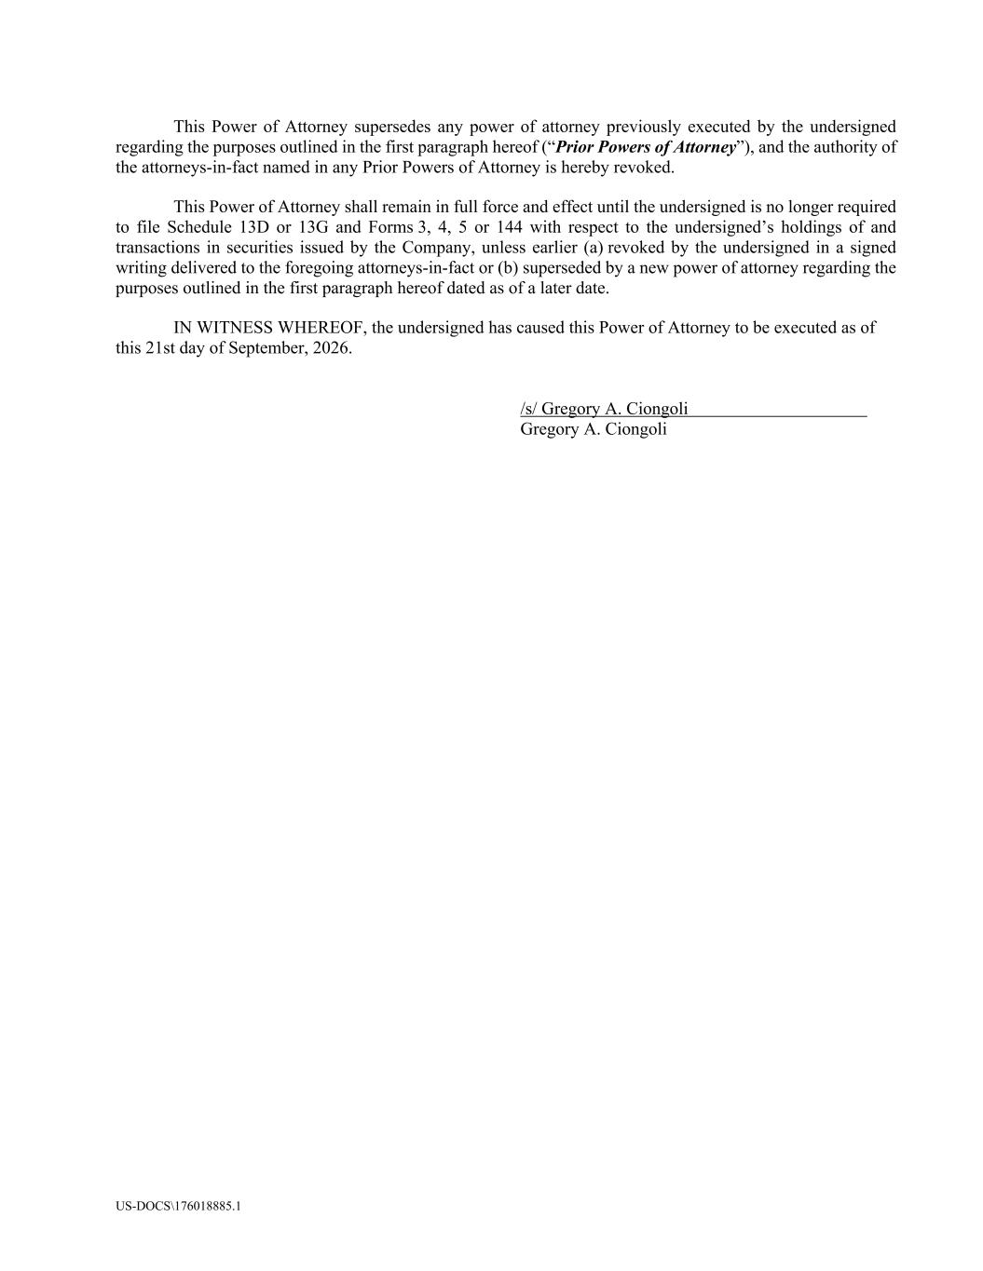
US-DOCS\176018885.1 This Power of Attorney supersedes any power of attorney previously executed by the undersigned regarding the purposes outlined in the first paragraph hereof (“Prior Powers of Attorney”), and the authority of the attorneys-in-fact named in any Prior Powers of Attorney is hereby revoked. This Power of Attorney shall remain in full force and effect until the undersigned is no longer required to file Schedule 13D or 13G and Forms 3, 4, 5 or 144 with respect to the undersigned’s holdings of and transactions in securities issued by the Company, unless earlier (a) revoked by the undersigned in a signed writing delivered to the foregoing attorneys-in-fact or (b) superseded by a new power of attorney regarding the purposes outlined in the first paragraph hereof dated as of a later date. IN WITNESS WHEREOF, the undersigned has caused this Power of Attorney to be executed as of this 21st day of September, 2026. /s/ Gregory A. Ciongoli Gregory A. Ciongoli

